Day Menu
- On Tables – 2 bread, 2 cheese (potted cheese? Tvarog? Fig? ), 2 butter, 2 pickles, 1 jam (rotate out, combine when at ½ and add a new dish.) Coffee/Tea
- 1pm – Hot sausage rolls, cheesy olives (served)
- 2pm – More bread, butter, pickled egg
- 3pm – Fried Cheese and pickled cabbage (served)
- 4pm – Add a pickle
Feast Menu
5pm – 1st Course – Soups (Sauces will be placed on tables either after the dish is served or right at the end of this course – Sauce Bob, Garlic cameline sauce, mustard sauce, ginger jance)
- Applade Ryalle
- 14. Cassia Soup
- 84. Green Bruet - egg and cheese soup.
5:30 - 2nd Course – Chicken & Sausage
- Subtlety - Poulaille Farcie (head table)
- Golden Dragon eggs (everyone)
- Red Dragon eggs (swimming sausage)
- Cumin Almond Chicken (everyone) Sauce
- Lemon water
6pm – 3rd Course - Pork
- Pork with Tallivent onion sauce
- Honey/Ginger Carrots
- Green salad
- Strawberry sekanjabin
6:30pm – 4th Course - Fish
- Poached Fresh Tuna with Yellow Sauce from Feast at Talmont
- Mustard leaf sauce
- Parry of Pesoun
- Sweet Tisane

6:45 – 5th Course - Tarts
- Mushroom tart
- Egg & Cheese Pies
- Une Faire Tarte
7pm – 6th Course - Sweets
- Golden Toasts
- Blanc Mange
- Tailliz
- Mint water
7th course - Nibbles - set out for snacking, after, or to take home
- Persian Boobs
- Baked Marzipan
- Seed cakes
- Spiced nuts
- Marzipan cookies
Notes
- Where available, original recipes follow in italic.
- Not all dishes were made and served at the feast.
- Much pre-cooking happened.
- Bread crumbs for the feast were made of fresh whole wheat lunch rolls.
- Wines were a cheap white, a cheap merlot, and a Carlo Rossi Burgundy.
- There are a number of notes appended to recipes.

Meats – pg. 5
- Subtlety - Poulaille Farcie (head table)
- Golden Dragon eggs (everyone)
- Red Dragon eggs (swimming sausage) (not made)
- Cumin Almond Chicken (everyone) Sauce
- Pork with Tallivent onion sauce
- Poached Fresh Tuna with Yellow Sauce from Feast at Talmont
Hot Appetizers
- Hot sausage rolls
- Cheesy olives (not made, just tested)
- Fried Cheese and pickled cabbage (didn’t use the cabbage, lack of time)
Cold Appetizers
- pickles Dilly beans, asparagus, beans, turnip/carrot, watermelon, strawberry
- pickled egg
- potted cheese
- Tvarog
- Cheeses – cheddar, mozz, cojack, brie
- Fig cheese
Other Main
- Mushroom tart
- egg pie
- Une Faire Tarte - veg/cheese tart
Sauces
- Sauce Bob
- Garlic cameline sauce
- Mustard sauce (Homemade hot wine mustard)
- Ginger jance
- Mustard leaf sauce (not made)
- Tallivent onion sauce (with pork)
- Yellow Sauce (with tuna)
Soups
- Applade Ryalle
- 14. Cassia Soup
- 84. Green Bruet - egg and cheese soup.
Sides
- Green salad (purchased)
- Parry of Pesoun
- Honey-Ginger Carrots
Sweets
- Golden Toasts (not made)
- Blanc Manger (not made)
- Tailliz
- Persian Boobs
- Seed cakes (not made)
- Spiced nuts
- Marzipan cookies
Drinkables
- Strawberry sekanjabin
- Sweet Tisane (not made)
- Lemon water
- Mint water
- Lime Water
Necessities
- Breads
- honey butter (not made)
- garlic butter
- Italian butter
- Bacon/blue butter
- Dill/Onion butter
- Blackberry jam

Meats
- Subtlety - Poullaille farcie/Gilded Chicken (head table)
- Golden Dragon eggs (everyone)
- Red Dragon eggs (swimming sausage)
- Cumin Almond Chicken (everyone) Sauce
- Pork with Tallivent onion sauce
- Poached Fresh Tuna with Yellow Sauce from Feast at Talmont
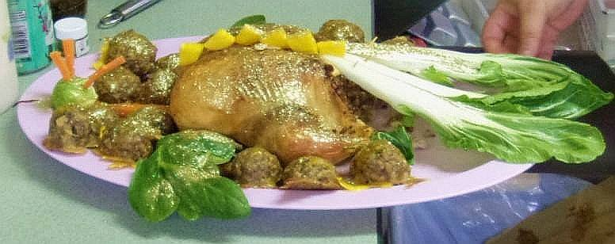
Golden Dragon with Red and Gold eggs (Poullaille farcie, feast version) - Whole chickens stuffed with meat, nuts, eggs, and spices, and gilded or colored, made into a subtlety. Subtlety directions and Recipes follow for the eggs & glaze.
This is a complicated set of dishes intended to be presented as sotelties at an event, with 2 chickens to be served to the high table for 20 guests. For a larger group, add one recipe of the stuffing mix for every 20-25 guests plus 4 pounds of chicken thighs baked with the thigh sauce, below and prepare extra mustard and other sauces (Cameline, Ginger Jance, etc.) for dipping.
Recipes were developed from period sources. Whole birds were not available.
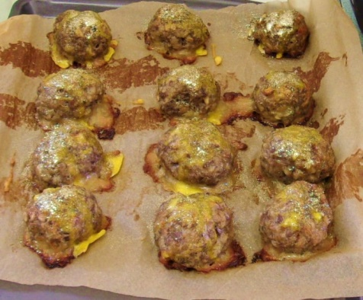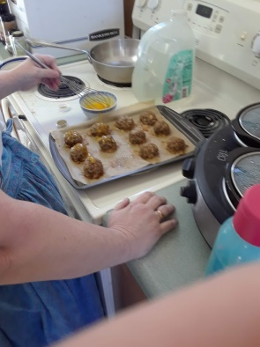
Stuffing and golden egg mix
- 2lbs mixed ground beef and pork
- 6 eggs, beaten
- 1 cup snack chestnuts (crunched)
- ½ cup pine nuts
- 1 1/2 cup grated mozzarella
- 4 tsp. Salsa Fina
- few thread saffron
- • 2 cup chopped onion
- • 5 cups cooked barley or rice
- 1 teaspoon dried tarragon
- 2 tsp. salt (or to taste)
Mix all of these together, well. Take about ½ of the mix and set aside for the eggs.
Chicken
- ½ the stuffing mix
- 2 roaster chickens
- Olive oil
- Salt
- Glaze (recipe below)
- Edible gold glitter (we used American Gold from www.ohsweetart.com ) It does not have any sugar in it!
Note – If doing this the morning of your feast, skip steps two and three.
- Cook the stuffing mix in the microwave, first for about 3 minutes and then 2 minutes at a time until no pink shows, breaking up lumps as you go.
- Drain (reserving juice for thigh sauce) and freeze in ziplock, shaking to keep it from clumping.
- About 30 minutes before you start assembling the chickens to bake, zap the stuffing 1 minute at a time until it’s slightly warm.
- Trim off extra skin and fat around the opening, leaving the tail stub.
- Stuff your chickens with the mix. Really pack it in. Any that is left over should be put back into the mix for the Dragon eggs and mixed in, well. Make sure the “tail” is still free.
- Rub the chickens all over with olive oil, then salt, lightly, and sprinkle with Salsa Fina.
- Lay belly down on foil on baking sheet or in a roaster.
- Using a bamboo skewer cut to size, prop the tail up so that it is sticking straight out. Cover the delicate areas of the legs, tail, and wings with foil to prevent overcooking.
- Place the bird in a 350° F oven and bake just until the skin begins to turn golden brown. Try not to overcook as the bird will fall apart if it becomes too tender.
- Remove from oven and very carefully remove the foil from the wings, etc.
- Immediately brush the entire bird with the glaze and sprinkle with glitter
- Return to the oven for just a few seconds, to set the glaze - be careful not to overheat as it will spoil the colors.
- Remove from oven, place each on its own serving platter, spreading wings and legs outward, and follow the instructions for the subtlety.
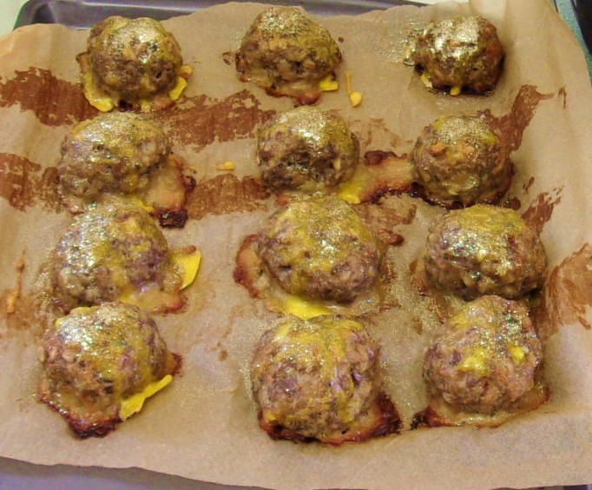
Glaze for Dragon and Golden Eggs
- 3 egg yolks
- Edible gold glitter
Golden Dragon Eggs - Are made of the remainder of the raw stuffing for the chicken, molded into eggs (meatball sized), placed in a foil pan and baked at 350F. You may add bread crumbs to the mix, if it is too moist to mold well. When the eggs are up to temperature (about an ½ hour, depending on size) brush with the glaze, sprinkle with glitter and return to the oven just long enough to set the glaze.
Red Dragon Eggs - Swimming Sausages
- 1 pound ground pork
- Tsp whole cloves and mace, mixed
- 2 Tbsp chopped fennel fronds
- 1 fifth Burgundy
- Bundle of fresh herbs (fennel and rosemary)
Mix the first three ingreadients together, well. Mold into balls. Put the balls into a foil pan. Add enough wine to float the sausages and herb bundle and bake at 350 until done by thermometer.
Soteltie instructions
While the birds are cooking, find 20 leaves of baby spinach, one medium onion, four stalks of celery, two brussels sprouts. 4 small beets (with leaves, if possible), 1 pimento-stuffed olive, 3 large carrots, a micro-plane, a little mayo, a vegetable peeler and 6-8 leaves of bok choy, plus a box of toothpicks, and a skewer.
Wash all of the vegetables.
Dragon claws – Take a narrow ribbon of spinach leaf and wrap each leg end. Cut one slice out of the center of the onion. Cut the slice into quarters. From each quarter take the four outside arcs of the ring. Place the smallest arc on the bird side of the leg end, curving away from the bird and the other 3 on the outside of the leg end curving toward the bird. (iow, claws and spur on each leg….)
Dragon neck - Peel the carrots. Grate two of them and mix with mayo. Break each stalk of celery in ½. Put the large halves down and fill with the carrot/mayo mix, then set the smaller ½ on top. Repeat for the 2nd neck.
Dragon Tail – Cut the stem end of each bok choy piece into a v-shape, so that they will fit up against each other. Pin them in place on the tail of the chicken with toothpicks inserted from underneath.
Dragon head – Use a toothpick to fasten the sprouts to the small end of the “neck”. Cut the third carrot into “sticks” no more than ¼ inch across by 2 inches long. Use the skewer to poke holes to insert them into the sprout for head spines. Some can also be poked into the neck, but you have to be careful not to split the celery. If you slice the olive across, carefully, you’ll have two green-rimmed red “eyes” to attach with pieces of toothpicks. Make tongues of a long strip of carrot (use a vegetable peeler to make the strip)
Dragon spines - Cut the stems from the beets, peel and slice to about ¼ inch, then cut each slice into 4 quarters. Keep these sorted by size. Insert ½ a toothpick into the curved side of each spine piece, then working from both the tail end of the bird and back from the neck, line these up along the back of the chicken, graduating from smallest to the largest, right above the middle of the chicken. If you have enough you can extend these onto the neck.
Dragon wings – Wrap the pointed section of each chicken wing with one leaf of spinach with the stem trimmed off. Trim stems from all the spinach and beet leaves. Make 4 piles (one for each wing). Lay the leaves out on the table first, checking how much room there will be for a wing on the platter. Put the farthest away down first, then the next, overlapping the leaves.
After that is all done, tuck a few each of the red and gold eggs in around the bird, where-ever they fit, and present. A sharp knife and cutting fork should follow each bird on a platter of mixed eggs, and then the sauces.
Thigh sauce and directions for extra servings of chicken) (for each 10 thighs)
- Reserved juice from stuffing mix
- 1 egg, beaten
- 3 Tbsp ground chestnuts and pine nuts
- 1./2 tsp. Salsa Fina
- 3 Tbsp minced onion
- 1/8 teaspoon dried tarragon
- Mix all this together
- Lay the thighs out on a baking sheet covered with foil.
- Sprinkle with salt.
- Sprinkle 3 tbsp grated mozzarella overall and bake at 350 until done.
Take a 3rd platter and fill with small cups of the following (at least one each for every 6-8 guests)
- wine mustard mixed with a little of the cooking liquid from the eggs to make it thinner.
- Cameline sauce
- Ginger Jance
- Salsa fina mixed with honey
- Or whatever strikes your fancy as good with meatballs.

65. Stuffed chicken.
Take your chickens, cut their throats, scald and pluck them, and make sure that the skin is sound and whole. Do not refresh it in water. Take a pipe of straw or other material, insert it between the skin and the flesh, inflate the skin, slit it between the shoulders without making too large a hole, and leave attached to the skin the thighs, feet, wings, and neck including the head.
To make the stuffing, take raw mutton, veal, pork and pullet dark meat, chop them all together, and crush them in a mortar with some raw eggs, good harvest cheese, good Spice Powder, just a bit of saffron, and salt to taste. Fill your chickens and restitch the hole. From the rest of your stuffing make quenelles shaped like cakes of woad. Cook them in beef broth and boiling water with plenty of saffron. Make sure that they do not boil so vigorously that they fall apart.
Spit your chickens and quenelles on a very thick [thin?] iron spit. Glaze them with green or yellow. For the yellow glaze, take plenty of egg yolks, beat them well with a bit of saffron, and put the glaze on a plate or other dish. If you wish green glaze, crush greens with the eggs. After your chicken and quenelles are cooked, put the spit on the dish where the glaze is, throw the glaze all over, and put it back on the fire until the glaze sets. Do this two or three times. Make sure that the fire is not so big that the glaze burns.
178. [Gilded chickens with quenelles.]
After the chicken is killed, break a bit of skin on the head, take a feather tube, blow in until it is very full of air, scald it, slit it along the belly, skin it, and put the carcass aside.
For the stuffing and the quenelles have some raw pork meat (it doesn't matter what kind) chopped with pork fat, white [chicken meat], eggs, good Fine Powder, pine nut paste and currants. Stuff the chicken skins with it (but do not fill them so much that they burst), restitch them, and boil them in a pan on the fire (but do not let them cook for very long). When the quenelles are well made, put them to cook with the chickens, and remove them when they are hardened. Spit the chickens on slender spits. Have the spits for the quenelles slenderer by half or more than those for the chickens.
Afterwards, you need to have some batter beaten from eggs until it can stand up in the pan. When the chickens and quenelles are nearly cooked, remove them and put them over your batter. Take some batter with a clean spoon, stirring always, put it on top of your chickens and quenelles, [and put them over the fire] until they are glazed. Do them 2 or 3 times until they are well covered. Take some gold or silver leaf and wrap them (first sprinkle them with a little egg white so that the leaf adheres better).
195. _To boil Sausages._ Queen-like closet
Take two pounds of Sausages, and boil them with a quart of Claret Wine and a bundle of sweet herbs, and whole Cloves and Mace; then put in a little Butter, when they are enough, serve them in with this Liquor and some Mustard in Sawcers.
Anja's interpretation of Cumin Almond Chicken from Le Viandier (#13)
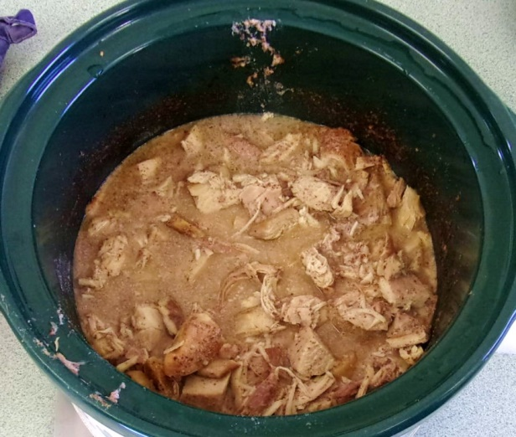
Ingredients
- 4 1/4 inch slices of fresh ginger, scraped of the skin.
- 4 chicken breasts, fresh or thawed
- 1/2 cup of almond meal
- Salt
- Ground cumin
- 1 cup red wine (used merlot)
- Water
- A Sprinkle of sliced almonds and cumin seed
Method
- In a large crockpot put your 4 ginger slices down and set the chicken pieces on top.
- Sprinkle almond meal on top of the chicken, reserve any left over when you have a thin layer.
- Add just a touch of salt, lightly sprinkled, then the cumin.
- Pour the wine overall, and then just enough water to have the chicken begin to "swim".
- Cook on low for 8 hours, flipping the chicken pieces once, and adding more water if not enough juice comes out of the chicken and they start to dry.
- Pull the chicken out and set aside to cool until you can handle it. (10 minutes or so)
- Taste the juice. If it needs more salt or cumin or wine, add a bit, then stir in any leftover almond meal and leave on the heat.
- Cut up the chicken. I aim for the largest pieces to be 1/2x1/2x2 inches, but it doesn't have to be diced.
- Add it back to the pot and turn down to "keep warm" or if you don't have that setting on your pot, turn it off and wrap in a heavy towel.
- You can serve from 15 minutes after the heat is turned down up to 2 hours later if it's on "keep warm". Wrapped in a towel up to an hour. Anything longer than that, refrigerate and re-heat.
- Garnish with sliced almond and a bit of cumin seed.
31. Pork Roast with onion sauce – Le Viandier
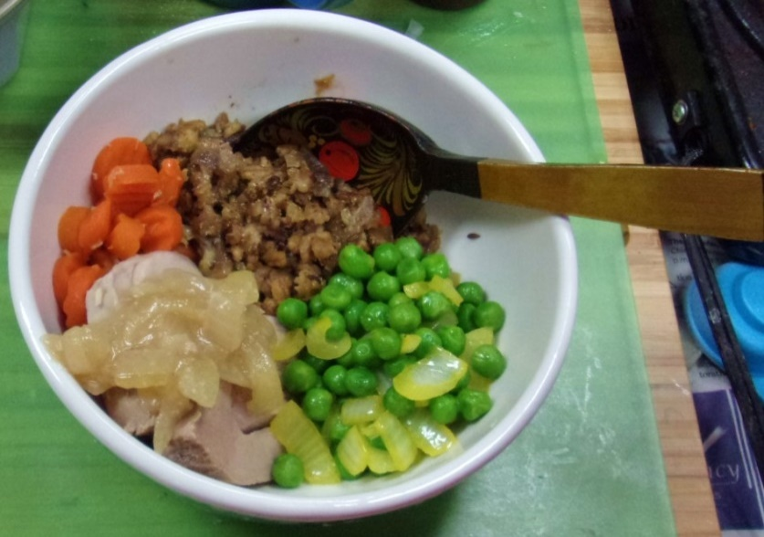
- Pork roast (tenderloin)
- 3 large onion, chopped
- 1 cup white wine vinegar
- Garlic powder
- Salt
- 1 stick butter
- ½ cup white wine
- Salt to taste
Method
- Put the roast into a crockpot on high.
- Pour 1 cup of the onion and the vinegar over the roast. Salt lightly and sprinkle with garlic powder.
- After 3 hours turn the roast other side up and spoon juices over.
- After another 1 ½ hours check the temperature of the roast. If it is at least 150F, pull it out to “rest” on the cutting board, covering lightly with aluminum foil.
- Melt butter in a large frying pan.
- Add the rest of the onions, white wine.
- Simmer until onions are transparent.
- Add the drippings and pan scrapings and onions from the crockpot and bring up to temp.
- Serve the sauce with the pork.
Sauce from Le Viandier - 31. Roast pork. - Eaten with verjuice. Some make a sauce (to wit, add garlic, onions, wine and verjuice to the roast drippings in the pan). In a pie; eaten with verjuice.

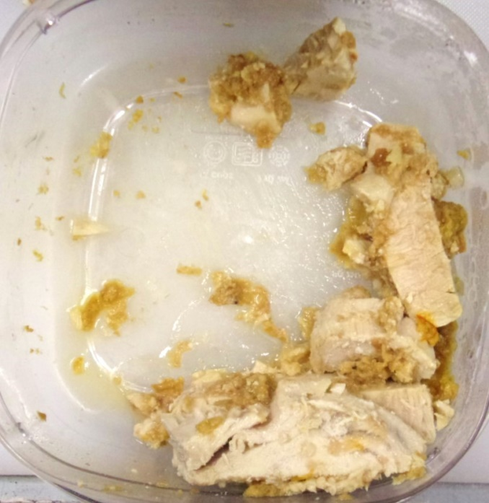
Poached Fresh Fish with Yellow Pepper Sauce - Le Ménagier de Paris - 8 servings
- 2 lbs. fresh tuna, thickly sliced
- sea salt
Method
- Wash the fish and pat it dry.
- Place in a pan with cold water to cover and about 1 heaping Tbsp. of salt per quart of water.
- Bring to a boil, lower the heat and simmer until done; start checking at about 10 minutes.
- Serve on a platter topped with Yellow Sauce.
Yellow Pepper Sauce (which has no pepper in it!)
- 1 large slice of bread
- 10 Tbsp. vegetable broth
- 3 Tbsp. white wine vinegar
- 1/2 tsp. ginger
- 4 threads saffron, crushed
- Sprinkle clove
- Sprinkle grains of paradise
Method
- Cube the bread and reduce to crumbs in a food processor.
- Put broth in a saucepan.
- Add the bread and stir well.
- Add ginger and saffron and bring to a boil.
- Add vinegar.
- Simmer until thickened. You might want to strain the sauce for a smoother consistency.
Yellow Soup or Yellow Sauce on hot or cold fish. Fry in oil, with no flour, loach, skinned perch or other similar fish, then grind almonds, and mix most of them with wine and verjuice and sieve, and put on the fire: then grind ginger, clove, grain and saffron, and stir with your bouillon, and when the soup has boiled, add your spices; and when serving add sugar, and it should be thick.

Other Main
- Mushroom tart
- Une Faire Tourte veg/cheese tart
- Anja’s Egg & Cheese Pie
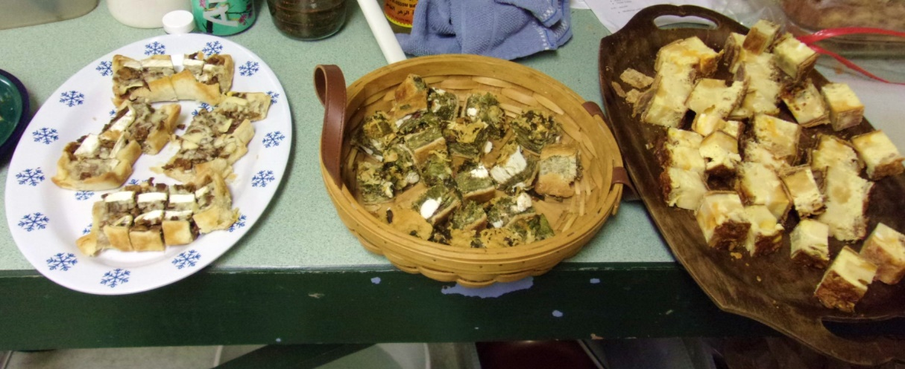
Anja’s Egg & Cheese Pie (8 standard servings) (created from descriptions)
- Saffron threads
- ¼ cup butter
- 1 purchased crust
- Cubed cheeses (cheddar, jack, mozz, swiss, gouda) about 2 pounds
- 6 eggs
- ¼ cup cream
- 3 slices bacon, cooked crumbled
- Salt
Method
- Melt butter in a cup and crumble the saffron into it.
- Cover and let stand overnight.
- Set out your crust
- Put cheeses into crust, at least touching, but not jammed in tight.
- Tuck bacon in and around, distributing evenly
- Chop some of the cheese smaller and tuck into blank spots and/or sprinkle over the top until the cheese level rises just to the crust.
- Mix butter/saffron (melt if necessary), eggs, and cream together thoroughly
- Sprinkle with salt and stir twice.
- Pour gently over tart, going around the tart from the outside to the inside, making sure that empty spaces are filled. Grate some parmesan or mozz over the top.
- Bake at 350 until solid (45min- 1hour) You can use the toothpick test.
Mushroom tart (makes 12) (created from several recipes)
- Purchased pie crust (two crusts)
- 12 oz canned sliced mushrooms
- 12 oz brie
- 3 tsp ginger
- 2 tsp clove
- 1 tsp cassia
- 1 tsp salt
- 6 eggs
- 6 tsp cream
- ½ cup grated parmesan (real stuff, not the green can)
Method
- Preheat oven to 325F
- Roll out the crusts and cut to fit cupcake pan
- Bake crusts for 5 minutes, then set aside to cool.
- Drain mushrooms thoroughly.
- Chop well
- Mix with spices and salt
- Cut brie into ¼ inch strips, cutting away the rind.
- Put a layer of mushroom, then a layer of brie in each tart shell. Repeat until used up.
- Beat eggs and milk with a fork.
- Pour over tarts, dividing evenly.
- Bake until done (clean toothpick)
- Sprinkle with parmesan and put back for 2 minutes.
- Either serve hot or refrigerate immediately and serve cold.
Une Faire Tourte (Vegetable-Cheese Tort) - Le Ménagier de Paris
yield - 1 pie
Pastry:
- 1 stick of butter
- 1/4 cup of water
- 4 strands of saffron, crushed
- 2 1/3 cups of flour
- 2 egg whites
Heat butter, water and saffron together in the microwave until the butter is melted. Let cool slightly. Add flour about ½ cup at a time, alternating with egg white, until you reach a good pie dough consistency.
Raise a coffin: build a shell with an 8" across flat bottom and 1" sides. This works best if you use a glass or ceramic dish with sides as an inside mold and build the pastry up the outside of the dish. Lift the dish out when built. Bake for 10 minutes at 325 degrees.
Filling:
- 7 oz. chard leaves
- 7 oz. spinach
- handful of chervil
- handful of dill or fennel fronds
- 8 oz. soft cheese
- 6 oz. medium cheese
- 2 eggs, beaten
- 2 tsp. Rafaella's Salsa Fina (ginger, cinnamon, grains of paradise, nutmeg, mace, cloves)
- 3 oz. freshly grated parmesan
Wash the greens and herbs very thoroughly. Discard stems, finely chop leaves and dry thoroughly. Beat soft cheese until smooth, add grated medium cheese and the greens. Mix until smooth then add the salsa fina and eggs. Fill the pastry shell and bake at 400 degrees for about an hour.
180. Parma tarts.- Take mutton, veal or pork meat, cook it, chop it appropriately, spice it extremely reasonably with Fine Powder, and fry it in lard. Afterwards, have large uncovered pies the size of little platters, with pastry sides higher than for other pies, and made in the manner of crenellations. The pastry should be strong so that it can hold the meat. If you wish, mix some pine nut paste and currants with the meat, and crumble some sugar on top. Take some boiled and quartered chicken, and in each pie put 3 or 4 chicken quarters in which to fix the banners of France and of the lords who will be in the [royal] presence. Gild them with sprinkled saffron to be more attractive. If you do not wish to depend so much on chicken, you need only make some flat pieces of roasted or boiled pork or mutton. When the pies are full of their meat, glaze the top of the meat with a little egg yolk and egg white beaten together, so that the meat will hold together more firmly for inserting the banners. Have some gold, silver, or tin leaf for gilding the pies in front of the banners.

Sauces Section
- Sauce Bob
- Garlic cameline sauce
- mustard sauce
- ginger jance)
- MustardLeaf Sauce
Sauce Bob - Sauce Bob is what the Stromgard culinary group called it to be funny. It's actually a recipe from Le Viandier de Tallivent.
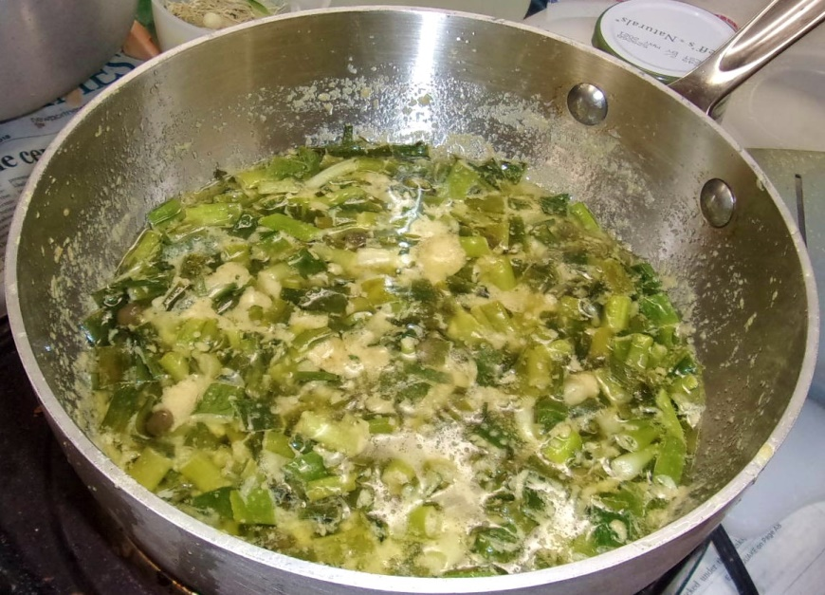
So we used:
- 2 stick butter (1/2 pound)
- 10 spring onions (rinsed with dry or slimy parts cut off)
- 1 large onion, minced
- 3 Tbsp pickled caper buds
- 6 Tbsp mustard
- 1/6 cup cider vinegar
- 1 tsp salt
- 3 Tbsp rice flour. (only if needed
Method
- Melt the butter in a frypan on high.
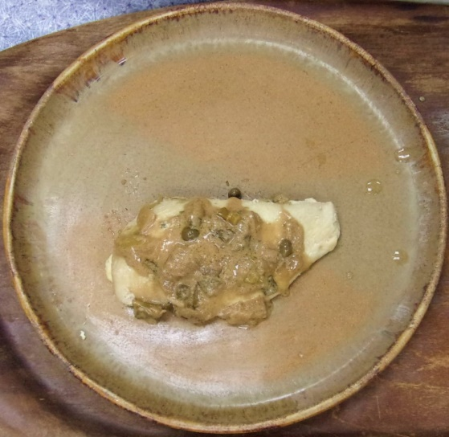
- Cut the onions and toss them into the butter. (We cut the shallot and added it likewise because it needed to be used up, otherwise use 10 spring onions)
- Cook until fragrant. (just a few minutes on high)
- Turn the heat to low.
- Add the mustard powder and stir it in, well.
- Add the capers, vinegar and salt.
- Stir well.
- Add rice flour (only if you think it needs it!) and stir until it cooks.
- Cook on low until flavors blend.
- Makes about 1 cup of sauce.
Barbe Robert [Sauce]. (aka Taillemaslee) - Take small onions fried in lard (or butter according to the day), verjuice, vinegar, mustard, Small Spices and salt. Boil everything together. (A 1583 cookbook quoted by Pichon et al., p. 109.)
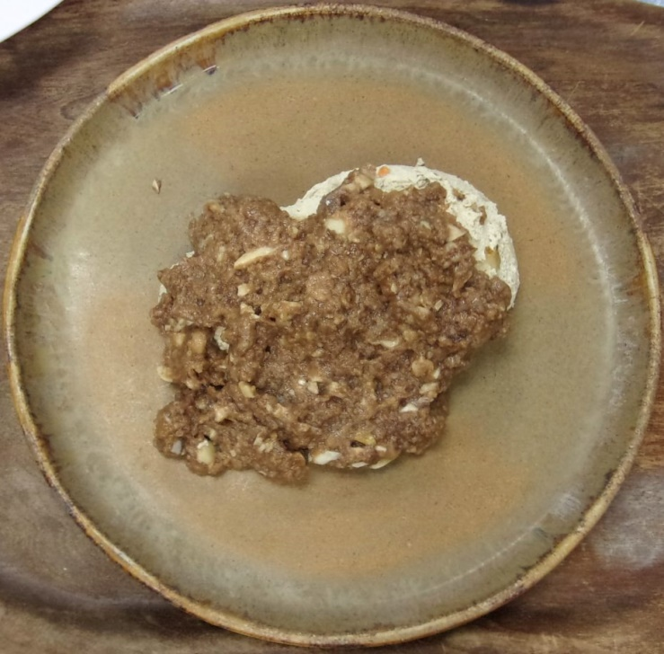
Garlic cameline sauce
- 1 bulb of fresh garlic, peeled and minced (or about ½ cup fresh, minced or ¼ cup dried) Do not use garlic powder!!!
- 2 cup bread crumbs
- 2 Tbsp Cassia/Cinnamon
- 2 tsp balsamic vinegar
- Water
- In a small saucepan stir the first 4 ingredients together.
- Add enough water to make it just slightly soupy.
- Cook over medium heat, stirring constantly until the breadcrumbs begin to “melt” and the sauce smooths out, adding water, if necessary.
- Keep warm and serve.
153. Garlic Cameline [Sauce] - Crush garlic, cassia and bread, and steep in vinegar.
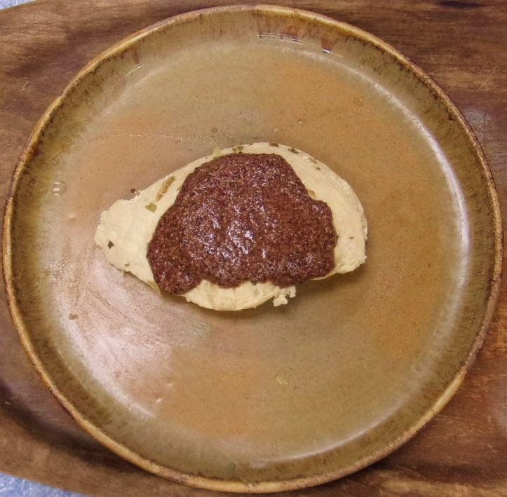
Mustard sauce – Use hot wine mustard recipe, then add another ¼ cup each of wine and vinegar.
Homemade Hot Wine Mustard
- 1/2 C dry mustard or better yet, cracked black mustard seed (measure after cracking)
- 1/4 C honey
- 1/4 C red wine vinegar
- ¼ cup red wine
- 1 T olive oil
- 1 t salt
- 1/2 t ginger
- ½ tsp cinnamon
- 1/2 t garlic powder
- 1/2 t horseradish
Place all ingredients in a small saucepan. Cook over medium heat, stirring constantly until mixture thickens (this only takes a few minutes). Store in an airtight container in the fridge for up to a few months. It’s a marvelous purple color! …and great as a sauce on bread.
Mustard Sources
The best way of making mustard is this: Take of the best mustard seed (which is black) for example a quart. Dry it gently in an oven, and beat it to subtle powder, and serse it. Then mingle well strong wine-vinegar with it, so much that it be pretty liquid, for it will dry with keeping. Put to this a little pepper, beaten small (white is the best) at discretion as about a good pugil and put a good spoonful of sugar to it (which is not to make it taste sweet, but rather, quick, and to help the fermentation) Lay a good onion in the bottom, quartered if you will, and a race (root) of ginger scraped and bruised, and stir it often with a Horseradish root cleansed, which let always lie in the pot till it hath lost its vertue, then take a new one. This will keep long, and grow better for a while. It is not good till after a month, that it have fermented a while. Some think it will be the quicker if the seed be ground with fair water, instead of vinegar, putting store of onions in it. The Closet Opened (sir Kenelme Digbie, KT) 1669 To Make Mustard
My Lady Holmsby make her quick fine mustard thus: Choose true mustard seed; dry it in an oven, after the bread is out. Beat and searce it to a most subtle powder. Mingle Sherry-Sack with it (stirring a long time very well, so much as to have it of a fit consistency for mustard) Then put a good quantity of fine sugar to it, as five or six spoonfuls, or more, to a pint of mustard. Stir and incorporate well together. This will keep good a long time. Some do like to put to it a little (but a little) of very sharp wine vinegar.- John Evelyn A discourse of Sallets, 1699:
Take the mustard seed, and grind one and a half pints of it with honey, and Spanish oil, and make it into a liquid with vinegar......
To make mustard for the pot, slice some horse-radish, and lay it to soak in vinegar, squeezing it well, and add a lump of sugar and an onion chopt. Use vinegar from this mixture to mix the mustard. From The Viandier of Taillevent (13th century), translated by Terence Scully [Cameline Mustard Sauce]:
Take mustard, red wine, cinnamon powder and enough sugar, and let everything steep together. It should be thick like cinnamon. It is good for any roast. Credit: The Viandier of Taillevent, edited by Terence Scully. (Ottawa: University of Ottawa Press, 1988)
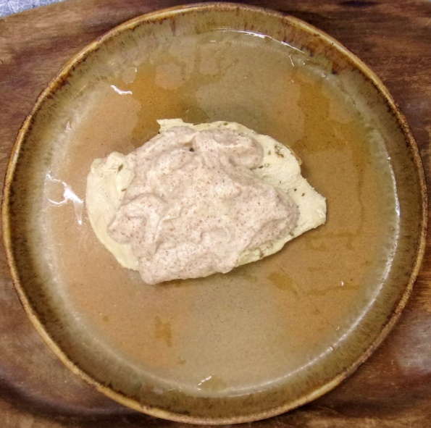
Ginger jance
- One “thumb” of fresh ginger root, peeled and minced
- 2 oz verjuice
- Almond meal (less than 1/2 cup)
Put the ginger and the verjuice into a small saucepan and heat to boiling.
Add almond meal, 1 tbsp at a time and stir well before adding more. You have enough almond meal when it begins to thicken up.
213. Ginger Jance [Sauce].- Take ginger and almonds without garlic, steep in verjuice, and boil. Some add white wine. (BN manuscript, p. 34.)
MustardLeaf Sauce by Jekka McVicar (pphoto by Stockbyte)
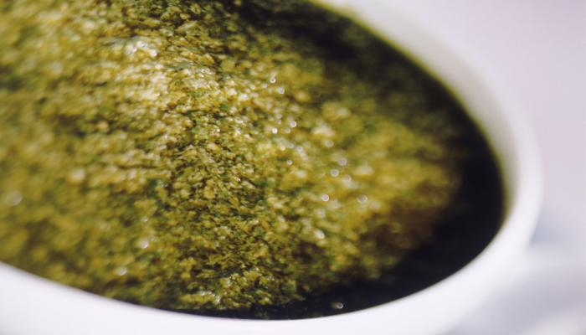
This is a lovely, spicy, warm flavored sauce that can be adapted by adding other ingredients. I often stir in hard-boiled eggs or bread crumbs soaked in vinegar, which adds different textures. Serve with fish, cooked meats, cheese and salads.
Ingredients
- 2 ½ cups mixed mustard greens (red or yellow), washed and roughly chopped
- 1 clove garlic, crushed
- 2-3 tbsp white wine vinegar or herb vinegar
- 1/3 cup olive oil
- Salt and freshly ground black pepper
Put the mustard leaves and garlic into a food processor and blend with 2 tsp vinegar. With the processor still running, add the olive oil in a slow stream, season to taste, then add the remaining vinegar if required.
Reprinted with permission from Jekka’s Herb Cookbook by Jekka McVicar, Firefly Books 2012.
[Anja’s note – There are a number of sauces that resemble this in period manuscripts. I just used a modern recipe!]
Soups
- Applade Ryalle
- 14. Cassia Soup
- 84. Green Bruet - egg and cheese soup.
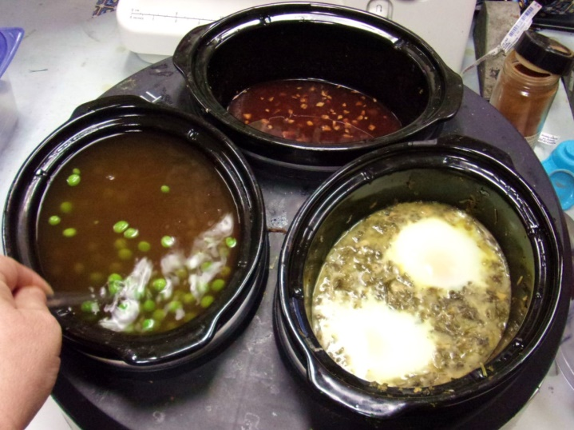
Soups - clkwise from top - Applade Ryalle, Green Brewet, Cinnamon Soup >>>>

Cassia Soup (based on Bera’s version, mixed with Tallivent and simplified)
- 8 20 80 Ingredient
- 4 cup 5 cup 5 qt Chicken Broth
- 1 tsp 2 1/2 tsp 3 1.2 Tbsp Cassia (rather than cinnamon)
- 2 Tbsp 1/2 cup 2 cup White wine
- 1 cup 2 1/2 cup 3 pound Frozen Green peas
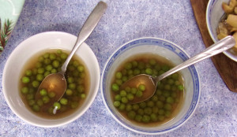
Method
- Bring all but peas to a boil and taste.
- Add cinnamon and salt, if necessary. (Can be saved at this point)
- Add peas, bring back to a boil.
- Turn heat to “keep warm” until serving
Cassia soup - Cook your chicken (or whatever meat you wish) in wine or water, quarter it, and brown it [in lard]. Take completely dry almonds cooked without peeling, plus plenty of cassia; crush, sieve, and steep in beef broth. Boil well with your meat and some verjuice. Take cloves and grains of paradise, crush, and add. It should be thick and strong. Le Viandier
Applade Ryalle (from Harleian manuscripts) Adapted from https://giveitforth.blogspot.com/2016/10/harleian-ms-279-ab-1430-cxxxv-applade.html?spref=fb
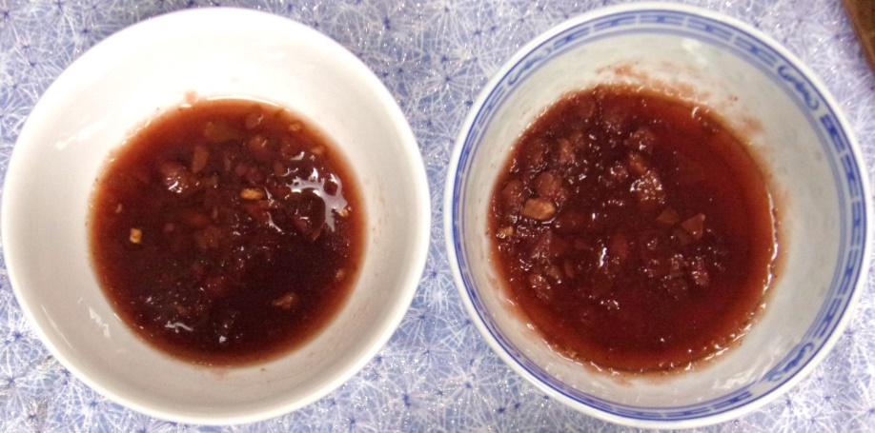
- 2 cups unsweetened applesauce
- 2 ¼ cup burgundy
- 1/2 tsp nutmeg
- 1/8 tsp clove
- 1/4 tsp cardamom
- 1 slice fresh ginger
- ½ cup honey
Heat and serve hot. Put extra honey on the table because some like it sweeter.
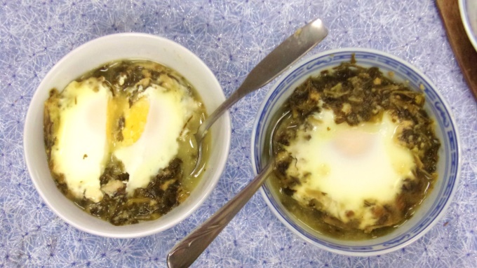
135 Apple Royal - Take apples and seeth them until they be tender and then let them cool; then draw them through a strainer; and on flesh day cast thereto good fat broth of fresh beef and white grease, and sugar and saffron, and good powder; and on a fish day, take almond milk, and olive oil, and draw there up with a good powder and serve forth. And for need, draw it up with wine, and a little honey put there to for to make it than sweet and serve it forth.
Tallivent - Green egg and cheese soup (bruet or brewet) - Anja's version
- Crockpot
- Parsley, 2 bunch
- Dab sage
- Dab saffron
- Bread crumbs, 1 cup cubes made 3/4 cup crumbs
- Dried Ginger cubes soaked in white wine
- Dried green peas cooked pureed (used 2 cups water)
- Cook all of the above together
- Grate cheese and add (cheddar? Parmesan?)
- Poach eggs in almond milk, maybe? Or water
- Add a little cooked bacon.
Take parsley, a bit of sage, just a bit of saffron in the greens, and soaked bread, and steep in puree [of peas] or boiled water. Add ginger steeped in wine, and boil. Add the cheese, and the eggs when they have been poached in water. It should be thick and bright green. Some do not add bread, but add almond milk.

Sides
- Green salad – Purchased mixed greens
- Parry of Pesoun
- Honey-Ginger Carrots
Perrey of Pesoun (Anja’s version)
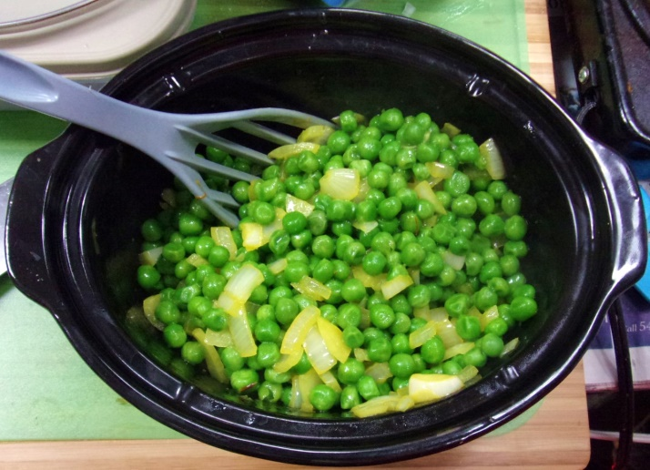
- 1 stick butter
- Pinch of saffron
- 2 lbs. frozen peas
- 1 Tbsp. salt
- 1 large onion, minced
Instructions:
- Melt butter in a cup and add saffron. Keep liquid for at least an hour, then cover and let sit overnight.
- Thaw peas and put into crockpot.
- Sprinkle with salt and turn on low.
- Melt saffron butter into saucepan.
- Add onion and cook until transparent.
- Stir into peas and let cook until heated through, then turn to keep warn until serving.
Original Recipe] - Perrey of Pesoun. XX.III. X.
Take pesoun and seeþ hem fast and covere hem til þei berst. þenne take up hem and cole hem thurgh a cloth. take oynouns and mynce hem and seeþ hem in the same sewe and oile þerwith, cast þerto sugur, salt and safroun, and seeþ hem wel þeratt þerafter and serue hem forth. - Forme of Cury, Pegge, Samuel, England, 13th Century
[Translated Recipe] - Take peas and seeth them fast and cover them til they burst, than take up them and cool them through a cloth. Take onions and mince them and seeth them in the same way and add oil, cast in sugar, salt and saffron and seeth them well thereafter and serve them forth.
References:
Pegge, Samuel. The Forme of Cury: A Roll of Ancient English Cookery, Compiled, about A.D. 1390, by the Master-cooks of King Richard II, Presented Afterwards to Queen Elizabeth, by Edward Lord Stafford, and Now in the Possession of Gustavus Brander, Esq. Wellington, NZ: Forgotten Books, 2008.
[FYI by Anja - It was pointed out that it's most likely that this was originally made with field peas, which are hard to get in the US unless dried, and that a better recipe would use split peas. I don't agree. This is going to be closer to the fresh field peas than the mush that results from dried split peas.]
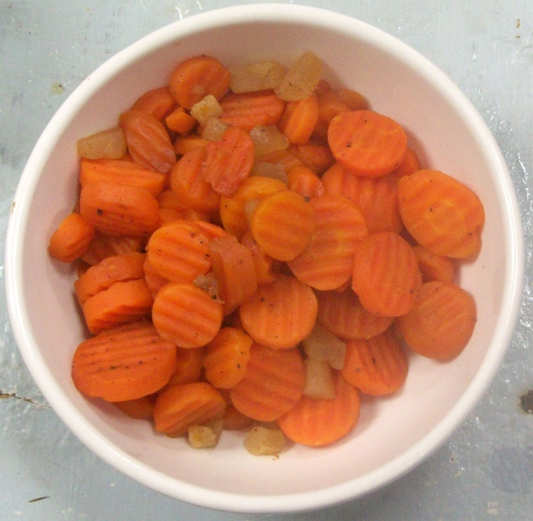Honey/Ginger Carrots – (described, only, but likely) These were probably boiled in a pot, but a crock next to the fire or in the oven is also highly likely.
Ingredients
- Water
- 2 pounds carrots, frozen, tri-color
- Honey
- 2 “thumbs” of fresh ginger
- Freshly ground nutmeg (if you have it) or a sprinkle of salsa fina.
- Crockpot
Method
- Put thawed carrots into crockpot
- Peel and chop ginger.
- Add to carrots and stir.
- Drizzle with honey, more or less to taste.
- Cook on low at least 3 hours, until carrots are tender, stirring at least once and to make sure the water level doesn’t go too low and let the carrots burn.
Note – Quick method is to add just enough water to cover the carrots in a pot on the stove and bring to a boil. Let boil for 15 minutes, then transfer to crockpot and continue as above.

Appetizers Section
- Hot sausage rolls
- Cheesey olives
- Fried Cheese and pickled cabbage
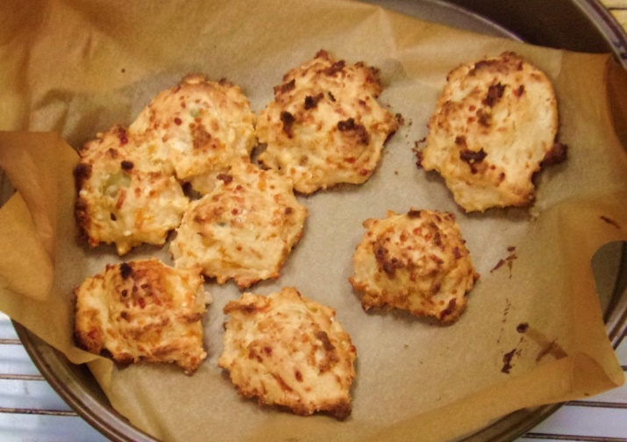
Hot sausage rolls or Cheesy olives - These can be done with pre-made dough sheets or crescent roll dough that comes in a can, as well to make it easy on yourself, or even bread dough. Dough recipe follows.
Ingredients
- Breakfast sausages or little smokies and/or
- Olives (any kind of stuffed, green)
- 1 dough recipe
- Cookie sheet
- Baker’s parchment
Method
- Cook your breakfast sausage until done, whether frying or baking.
- Drain (or drain little smokies)
- Cut breakfast sausage into two pieces.
- Prep cookie sheets with baker’s parchment
- Using the dough recipe below, make a splodge of dough about ½ an inch larger that then width/length of the sausage and top with a similar amount. . or
- Roll each in dough sheet dough after sprinkling the inside of the dough sheet with garlic powder and place seam down on cookie sheet
- Bake at 400 for about 10 minutes or 325 for 20, until they brown.
- You can do the same with the drained green olives
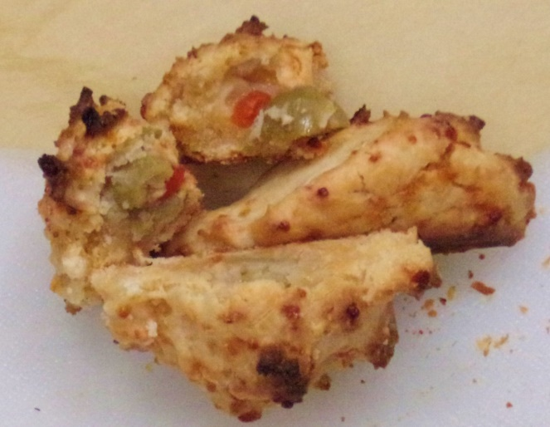
Red LobsterStyle Cheese Garlic Biscuits Recipe By Diana Rattray - Updated 04/02/18 Copycat recipe
Ingredients
- 2 cups buttermilk baking mix, homemade or Bisquick
- 2/3 cup milk
- 1/2 cup sharp Cheddar cheese (shredded)
- 1/4 cup butter (melted)
- 1/4 tsp garlic powder
Method
- In mixing bowl, mix ingredients until soft dough forms, then beat vigorously 30 seconds.
- Drop from spoon onto ungreased baking sheet and bake at 450° until golden brown, 9 to 10 minutes.
Anja’s Note - Because of time constraints for this feast we just sliced and fried the cheese and served it around hot, one batch at a time.
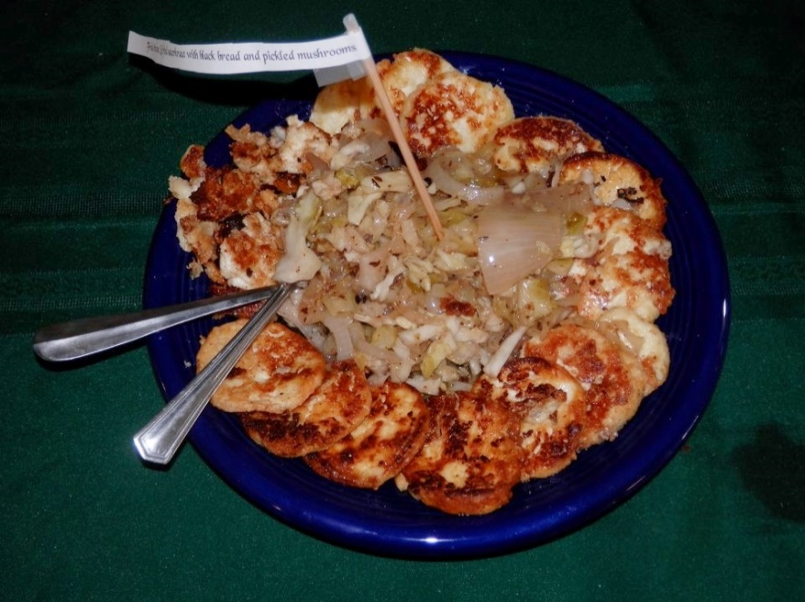
Fried cheese and fried sauerkraut - 1 recipe of Schiz (recipe follows) and 1/2 cup sauerkraut or pickled cabbage, ½ cup pickled mushrooms serve 6 for a snack, 12 for a feast.
- Melt 1 stick of butter in the frying pan over medium heat.
- Add slices of schiz to butter until pan is full. Salt lightly. (Mushroom can slices can take 6, soup can is 3)
- Let fry on medium heat, sliding a thin spatula under each slice and moving them to keep them from sticking. When slightly browned flip and cook some more.
- When browned on both sides remove to a warm plate and repeat until all is fried.
- You may find that you need to add butter on the 3rd go-round.
- Rinse your sauerkraut in cool water and let drain. (Or use cabbage pickle)
- When the cheese is all done add ½ cup of sauerkraut to the butter in the pan. If there’s only a thin skin of butter, add another ½ stick.
- Fry until hot, remove to plate (I usually put the cheese slices around the outside and pile the kraut in the middle)
- Repeat until it’s all hot.
- Serve with pickled mushrooms in a small bowl in the center of the kraut.

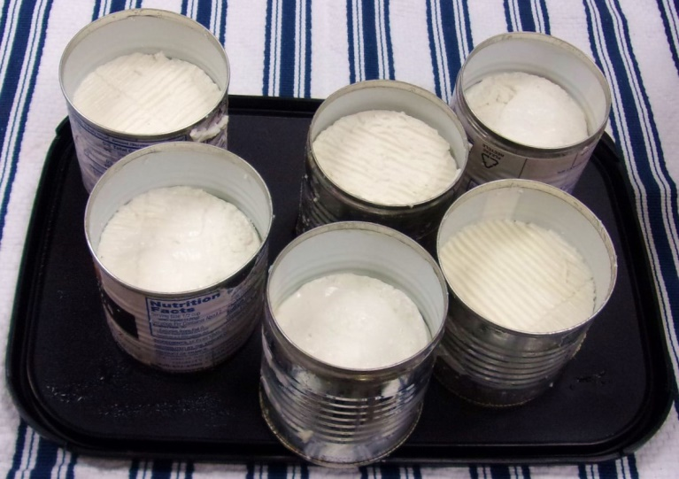
Schiz – Now this cheese is Italian, but it has the characteristics and flavor of a cheese that my Baba used to get from a German butcher. We’ve been molding it to get the right size/shape to cut for frying and flavoring it with caraway. This recipe is edited to “steps”. Full recipe here: http://wp.me/p8ngGY-l9 (Our cooking instructions follow the cheese recipe, which is made 3-4 days ahead.) Pickled Mushrooms and Pickled Cabbage (used instead of sauerkraut) found in the pickles section.
Ingredients
- 1 gallon of milk (not ultra-pasteurized)
- 1/2 tablet veg rennet
- (optional) Calcium chloride for pasteurized cold stored milk
Tools
- Good thermometer.
- Large pot
- Ladle
- Knife or cake spatula to cut the curds
- A basket mold or any other good draining mold. (We use tin cans on a cheese mat.)
Steps
- Heat milk (with caraway) slowly to 96° F (35° C), then take it off the heat source.
- Add 1/2 tablet rennet.
- Stir for one minute, then stop it moving
- Let set for 30 minutes.
- Cut the curd about 1-2 cm between cuts,.
- Return to the heat and cook 20-30 minutes on low. Monitor the temperature so that it doesn't go above 120°.
- Remove the whey with a ladle to about an inch above the surface of the curds.
- Transfer the curds to the mold and allow the whey to drain.
- Refrigerate.

Sweets Section
- Golden Toasts (not made)
- Tailliz
- Persian Boobs
- Baked Marzipan
- Seed cakes (not made)
Golden toasts – French toast (1 serving is 4, 2 inch squares) 30 servings
- 15 slices thick-sliced heavy bread
- 6-8 eggs
- 2 Tbsp cream
- Nutmeg
- 2 sticks butter
- Raw Sugar
- Cut thick-sliced heavy bread into 2 inch squares.
- Toast
- Beat eggs together with a tiny bit of milk and some nutmeg.
- Dip toasts immediately before frying.
- Fry on butter or bacon grease until cooked.
- Arrange on a warm platter sprinkled with sugar
181. Golden toasts.- To make golden toasts, take some hard white bread, slice it into square toasts, roast them a bit on the grill, coat them very well in beaten egg yolks, brown them in good hot lard on the fire until fine and very golden, remove them from the pan, and put them on plates with some sugar on top.
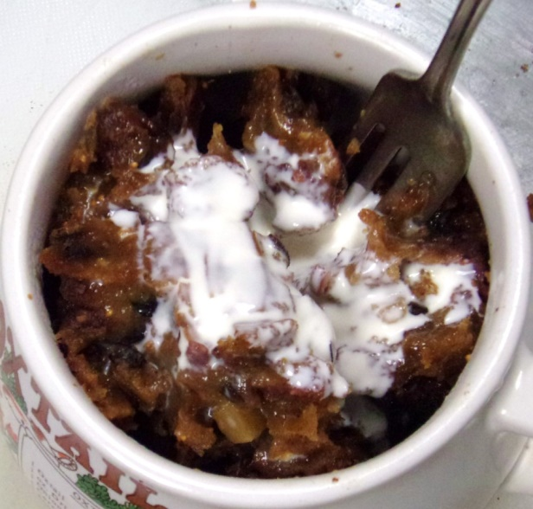
Tailliz (Lenten slices) - Le Viandier de Taillevent x3
8 servings
2 cups almond milk
1/3 cup superfine sugar
4-5 slices dried bread without crusts, diced small
pinch saffron threads steeped in 1 Tbsp. hot water
3/4 cup raisins
3/4 cup chopped dates
10 dried small (Adriatic) figs, chopped
Combine almond milk and sugar and bring just to a boil, add in bread crumbs and stir until smooth. Stir in saffron and water, then add fruit. Cook at a simmer for 10-15 minutes stirring constantly. Pour hot mixture into molds or waxed paper-lined pan and cool.
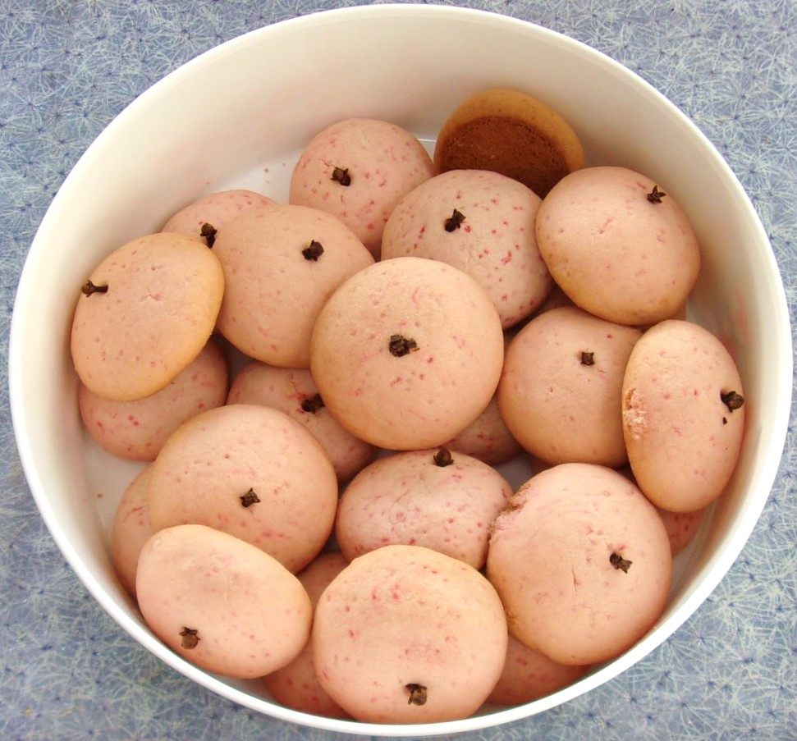
Persian boob cookies - Stephanie Booth (Anja’s changes)
Ingredients
- 2 1/4 cup plain flour
- 3/4 cup butter
- 7/8 cup powdered sugar
- 1/8 cup red colored sugar
- Whole cloves for nipples
Method
- Mix all ingredients, divide into roughly 24 boob shaped biscuits (don't forget the nipples!)
- Bake for 40min at 325F. These are supposed to lightly brown on the bottom, only. Don’t underbake, but overbaking will cause them to change race….
Marzipan Cookies
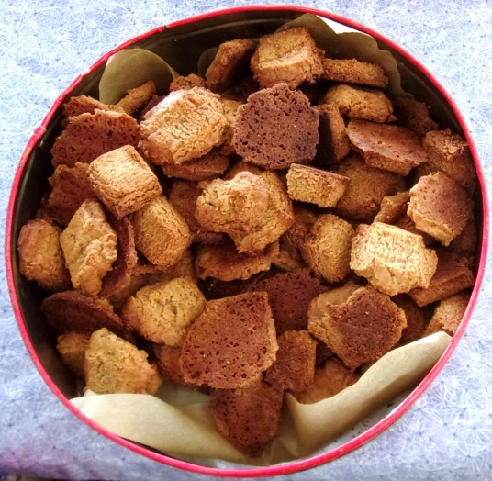
- 1 recipe basic marzipan aged at least 1 month (2 cups) (recipe follows)
- Cookie sheet
- Baking parchment
Method
- Preheat oven to 325F
- Cut your marzipan into ¾ or 1 inch cubes and place 3 inches apart on baking parchment on a cookie sheet.
- Bake at 325 for 10 minutes until edges begin to brown.
- Sprinkle with a flavored or colored sugar.
- Let cool on parchment, then slide into an airtight container.
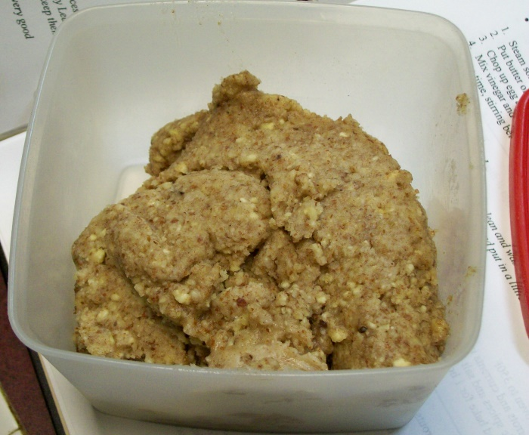
Basic Marzipan
- 1 pound confectioner’s sugar
- 1 pound almond meal
- ¼ to ½ cup of vanilla extract (recipe follows) or rosewater
- Food processor with blade
- 2 to 2 ½ cup air-tight container
- Hard spatula
- Put almond meal in one side of food processor and sugar into the other side.
- Pulse until mixed well, shaking or stirring as needed.
- Dribble the vanilla down the “snoot” of the food processor, slowly, with it running on medium speed. It will first resemble crumbs, then begin to clump and the food processor will slow, audibly.
- When it suddenly starts rolling a ball of stuff around, stop dribbling and turn off the food processor.
- Scrape the dough into a 2 to 2 ½ cup airtight container, getting even the dry stuff the sometimes remains on the bottom. Dribble a few drops of your vanilla onto this last, then seal up and let stand at least overnight before using.
Note – If you don’t have a container this size, press the dough into itself, tightly and dribble a few drops of vanilla on top.
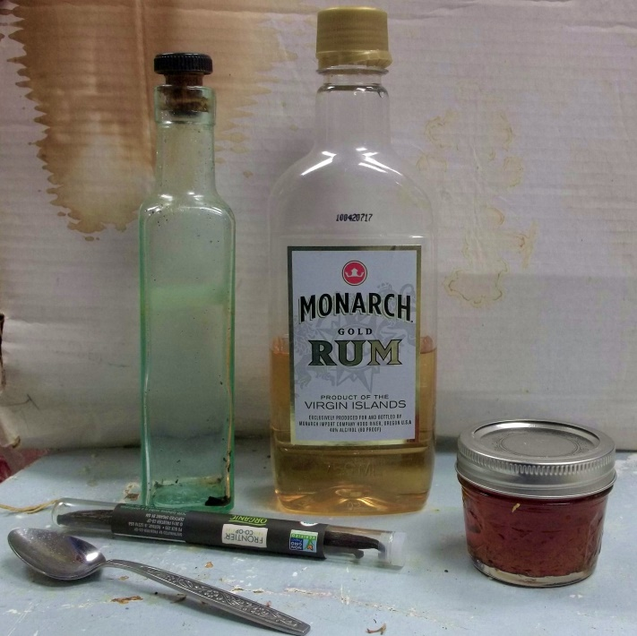
Vanilla extract
- 3 good vanilla beans
- Fifth of rum
- Sharp knife
- Open your rum bottle
- Using the sharp knife, split two beans lengthwise and drop into the bottle.
- Chop the other into ½ inch pieces and drop into the bottle.
- Put in a cool place and agitate daily for at least a month before using. Keep the beans in the bottle.
- Beans may be used a 2nd time, then dump the chopped bean (use it in coffee!), chop the split beans and split another.

Seed Cake (not made in time for the feast)
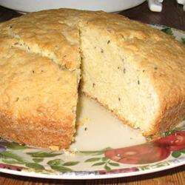
PERIOD: England, 16th & 17th centuries | SOURCE: Book of Cookrye and The English Huswife | CLASS: Authentic
DESCRIPTION: A sweet seed cake

ABOUT THIS RECIPE:
This is an original recipe, based on cake receipts from A.W.'s Book of Cookrye (1591) and The English Huswife by Gervase Markham, 1615. These sources are not medieval, but this type of sweet, almost bread-like round cake was very common during the Middle Ages, and this recipe is an approximation of how this delectable may have been prepared during that earlier period. A round cake such as this is described in Chaucer's Canterbury Tales, where it is compared to the shape of the medieval round shield, the Buckler.

MODERN RECIPE:
- 1 ½ cups unbleached flour
- 1 cup cracked wheat flour
- 1 pkg. yeast
- 1/8 cup warm (100 degrees) ale
- 1/8 tsp. salt
- 4 oz. (1 stick) sweet butter
- 3/4 cup sugar
- 2 eggs, beaten
- 1 tbs. seed (crushed anise, caraway, coriander, cardamom, etc. - choose something flavorful & pleasant)
- ½ - 1 cup milk
Sift together the flours and salt; set aside in large bowl. Dissolve yeast in warm ale, along with 1/8 tsp. of the flour mixture. Cream together the butter and sugar. Beat in eggs and seeds. Make a well in the flour and add the dissolved yeast. Fold flour into yeast mixture, then fold in the butter. Slowly beat in enough milk to make a smooth, thick batter. Pour batter into an 8" round greased cake pan. Bake in middle of oven at 350° F for 45 minutes, or until a toothpick inserted in the center comes out clean. Let cool slightly before turning onto a cake rack.

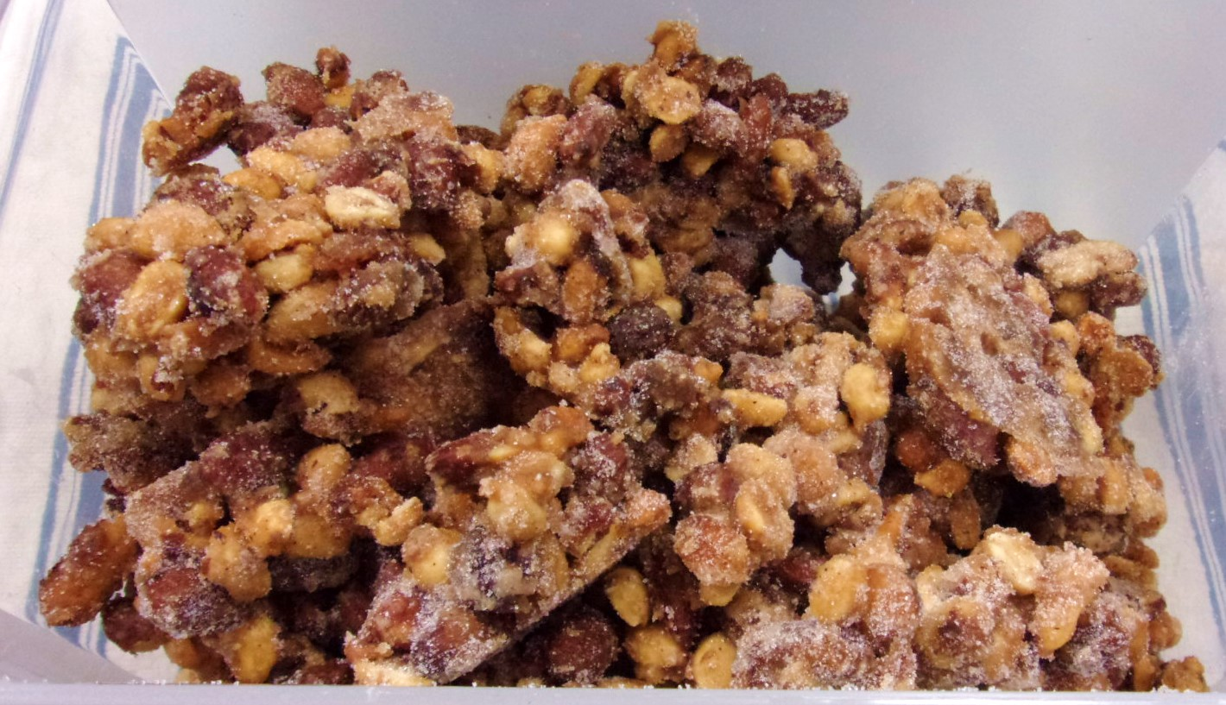SLOW COOKER Spiced Nuts – There are notes of sugared nuts and nuts that have been spiced in late period. Nothing that I have found for recipes, though, and these are a modern “yum”!
INGREDIENTS
- cooking spray
- 1 1⁄2cups granulated sugar
- 3tablespoons ground nutmeg
- ½ teaspoon ground mace
- 1⁄8teaspoon salt
- 1egg white
- 1 1⁄2teaspoons vanilla extract
- 3cups pecans
DIRECTIONS
- Spray slow cooker liberally with cooking spray.
- Combine sugar, nutmeg, mace and salt; whisk well and set aside.
- In a large bowl, whisk egg white and vanilla until frothy.
- Add nuts and toss to coat thoroughly.
- Pour in sugar mixture and again toss thoroughly to coat.
- Pour coated nuts into slow cooker.
- Cover and cook on low 2 hours.
- Turn to high and stir every 20 minutes to prevent burning.
- Lay out a piece of baking parchment.
- Pour nuts onto parchment, spread out and let cool to room temperature.
- Store in an airtight container.
Drinkables Section
- Sweet Tisane
- Hot Mint tea
- Lemon Water
- Lime Water
- Mint water
- Strawberry Sekanjabin
Sweet Tisane - Le Menagier de Paris – Interpretation and Translation by Mistress Kiriel du Papillon (OL, OP)
- A short gallon of water (3.7 litres)
- A generous 2/3 cup barley (160g)
- 7 dried figs - chopped into quarters
- About 1 tsp of stick licorice (4 grams) – this is the dried stalk of the licorice plant (you might find this in an Indian supplies shop)
- Rock sugar (used raw sugar)
- Bring the water to the boil in a large pot.
- Add the barley, figs, and licorice stick.
- Boil gently till the barley bursts (about 45 minutes).
- Strain through cloth (you might find it easier to do a first draining through a colander) and pour the liquid hot into goblets, into which a small lump of rock sugar has been ground.
This recipe makes a warming, somehow soft tasting tisane, which is both soothing and pleasant. Give it a try!
Sweet Tisane. Take fresh running water and bring it to boil, then for every one sextier[1] of fresh water a generous porringer of barley, and it is not important if it has husks, and for two parisis[2] of licorice, similarly, figs, and then boil it until the barley bursts and then strain it through two or three layers of cloth, and put in each goblet an abundant amount of rock sugar. This barley is then good to give to poultry to fatten it.

Hot Mint Tea (Anja) – Pour 1 quart of boiling water over a handful of dried mint in a heat-proof pitcher or tea pot. Let steep for 5. Strain as you serve or before.
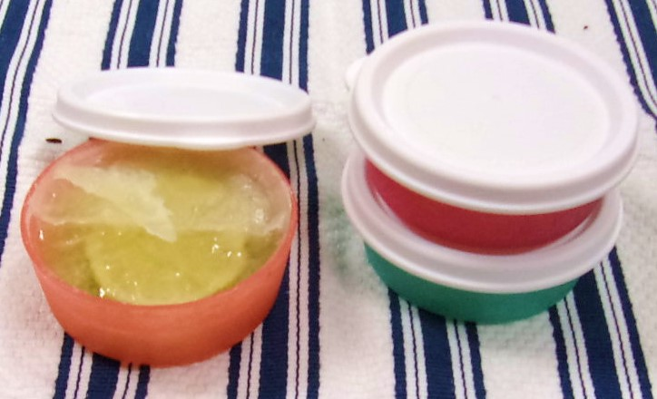
Lemon Water & Lime Water (Anja) – Very simple non-sweet drinks
To an ½ gallon jar full of water add slices (peel and all) of 1/3 a regular lemon or lime or all of a small lime (such as key lime) Let stand overnight in the fridge and serve cold.
Mint water - Strawberry Sekanjabin (Anja) - The method for both of these is the same and both are best served cold.
At least 12 hours before serving, using an iced tea maker, add to the basket a handful of mint leaves plus ¼ cup of vinegar and 2 Tbsp honey or the contents of a jar of spiced strawberry pickle and run it. Refrigerate for at least 11 hours.

Necessities Section
- Bread
- potted cheese
- Tvarog
- pickles
- honey butter, garlic butter and other flavors
- Jam
- Mustards
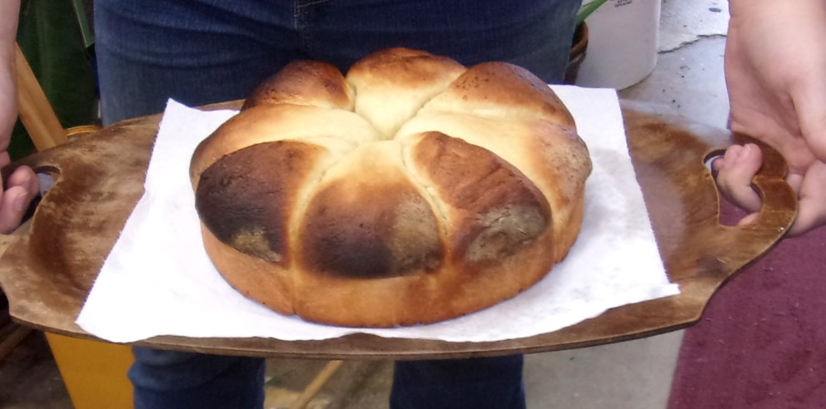Loren’s basic bread loaf recipe for a 2 pound breadmaker
- 1 1/2 cups warm water
- 1/4 cup plain sugar
- 1 Tbsp salt (approx or less)
- 2 1/2 tspn yeast
- 1 Tbsp bacon fat (or less to taste)
- 4 Cups Unbleached cheap white flour
Mix it all together until it resembles bread dough, let it rise a couple times, somewhere warm, like in an oven at 125, until it looks like something that should be cooked, then scorch it at 350 degrees for about half an hour until it appears edible. Modify these directions as needed to make it work.
[Anja’s translation: He uses a bread maker on dough cycle, so dump stuff into the bucket and turn the thing on. Check it after about 10 minutes (this depends on your breadmaker, during the 2nd mixing…..) to make sure the flour is all “in”. When the cycle ends, shape it and let rise in a 125 oven for 15-30 minutes. Bake at 350 for 20-25 minutes. ]
Variations
- Rye/Caraway – (Also Barley, Oat bread, Pea bread) - Replace 2 cups of the white flour with rye and add 1 1/2TBSP caraway seed. This dough usually takes additional water. Check after the first “rumpus” of the bread maker (on mine, after 10 minutes)
- Seed bread – Add ½ cup of “seeds”, usually a mixture of millet, flax and sunflower for us, but your mileage may vary.
- Italian Seasoning Bread – Add one packet of 4 seasons Italian Salad Dressing mix, plus 1 TBSP minced garlic.
- Olive/Caper – Add 1 can of olives, drained, ½ that of capers – bread comes out flat.
- Sesame – Add ½ cup of sesame seeds. Brush with butter and sprinkle with seeds
Note - Both of the rolls can be done in a breadmaker, if the yeast/water/sugar is allowed to proof for 10 minutes before starting. Extra rising time may be required.
Barley bread rolls – Regular bread recipe, but with all the flour replaced with barley flour.

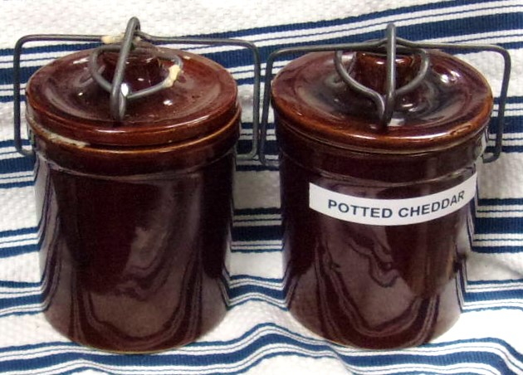
Potted Cheddar with Bacon and Shallots
- Cook Time: 30 minutes
- Total Time: 30 minutes
- Yield: about 1 pint
Ingredients
- 2 tablespoons butter
- 8 ounces bacon
- 2 medium shallots, sliced paper thin
- 12 ounces sharp cheddar cheese shredded
- 1 cup heavy cream
- 2 tablespoons burgundy (or dry or cream sherry or even dark beer, have done it with all of these)
Method
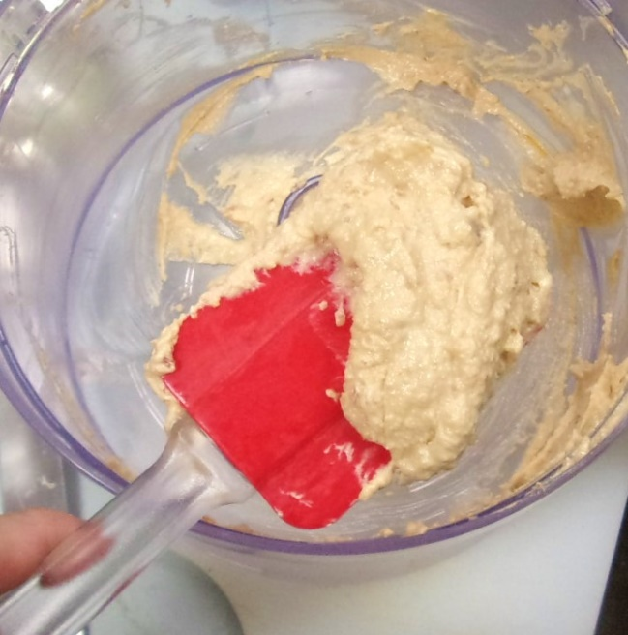
- Melt butter in a pan and fry bacon over medium-high heat until cooked through and crispy.
- Remove the bacon from the pan, and set the strips on a rack to cool slightly and de-grease.
- Decrease the heat to medium-low.
- Toss the shallots into the hot fat, and sauté them until deeply fragrant and browned, about 15 minutes.
- Combine bacon and cheddar in a food processor and pulse until well-blended.
- Add the shallots and pulse until mixed, then the cream, then sherry to the bacon and cheddar, and continue to process them together until they form a smooth, spreadable paste.
- Spoon the cheese spread into a jar or into ramekins, and either serve right away or store, carefully covered, in the fridge for up to a month. Remember to bring the potted cheddar to room temperature before serving, and spread over crackers or bread as an appetizer or starter.
Anja’s Tvarog – This is not quite the period method, but it works.
- ½ gallon jar
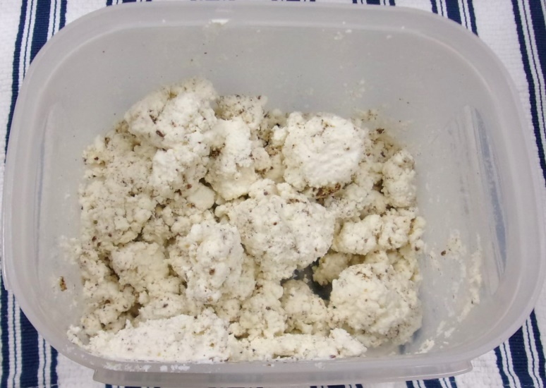
- 1 ½ cups cultured buttermilk
- 4 1/2 cups milk
- ½ cup cream
- ¼ cup salt (or less, to taste) See note.
- Shake together well and set in a warm place for 24-48 hours (we use an incandescent bulb and a box)
- When it begins to separate and feels thick (like sour cream) pour out into a large cookpot.
- Slowly bring up to 120F and cook for 20-40 minutes, stirring well.
- Strain through 4 layers of cheesecloth and hang to drip out at least 2 hours.
- Then set the cheesecloth and contents into a strainer over a bowl and put in the fridge for 8-12 hours.
- Tip out into a small box, break up and salt, then smoosh back together and let stand for at least 24 hours before using.
Note – If you use no salt the cheese must be used within 24 hours. With the salt, it keeps for a week, at least. Unsalted tvarog is what is used in the Tvarohový Babovka.
Kmínový Tvarog
- 1 recipe tvarog
- Shaker of salt
- Container of caraway seed (or cheese salt)
- Several ½-cup gladware boxes or a couple of straight-sided pint jars
- Once your tvarog has finished draining (overnight) spoon by the TBSP-full into ½ cup size gladware.
- Add a few shakes of Salt and a pinch of caraway and press down with a spoon.
- Repeat until you have a full container, put the lid on and the repeat until your tvarog is all used up.
- Alternatively, you can mix it all in a large bowl (having done the spoon/spice routine) and then pack it into jars. (1/4 cup of spice/salt, total)
- Refrigerate immediately. This should be allowed to sit at least overnight, preferably for 48 hours, and then used by the end of the week.
Cheese Salt
1 part each, cracked mustard seed, caraway and dried horseradish and then 3 parts salt. Keep airtight in a glass jar.
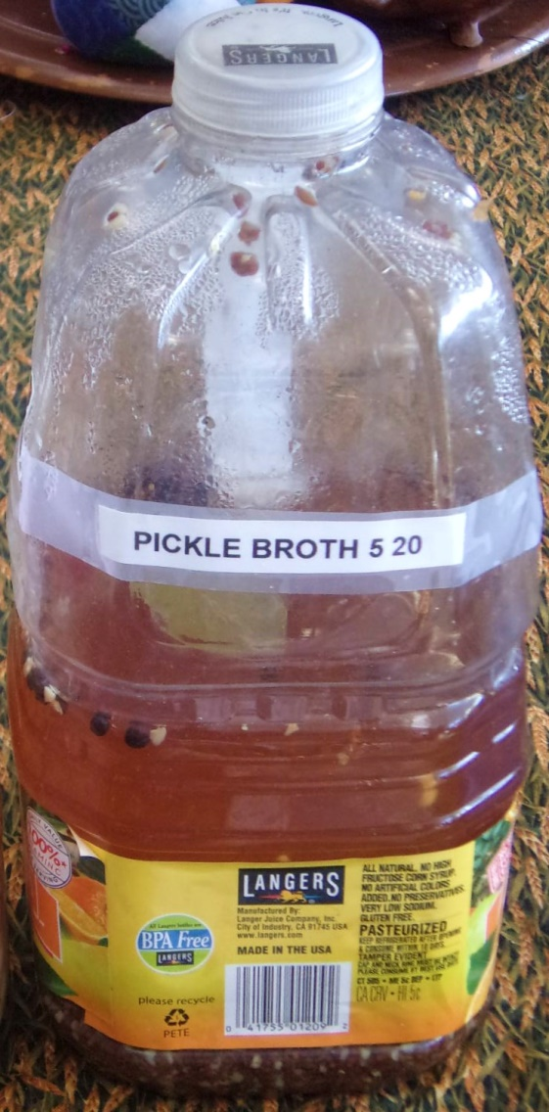
Gallon Recipe for Pickling broth – This does not make quite a full gallon and amounts are not exact (not for someone who is OCD, anyway). You can boil some more vinegar to top it up or just leave it.
Ingredients
• 2 garlic bulbs
• 2 lg onion
• 6 cup water
• 5 cup cider vinegar
• 2 cup sugar
• ½-1 cup salt (depends on taste)
• 1/3 cup dill (may be changed for other spices/herbs)
• 1/3 cup celery seed (may be changed for other spices/herbs)
• 1/3 cup caraway seed (may be changed for other spices/herbs)
Method
1. Peel, stem and root the onions.
2. Cut in ½, then slice across the grain.
3. Put into the gallon container. (You can feed ½ ring at a time.)
4. Peel the garlics. Put in the pot.
5. Add the ingredients to the pot.
6. Bring to a boil.
7. Stir well.
8. Pour into gallon container.
9. Repeat with other ½ of ingredients.
10. Cool in fridge.
11. Store in frig, ready to eat next day, keeps several weeks.
.
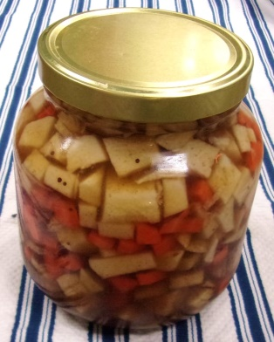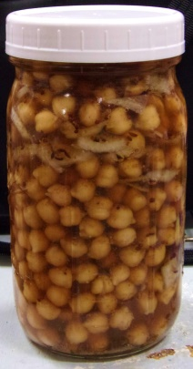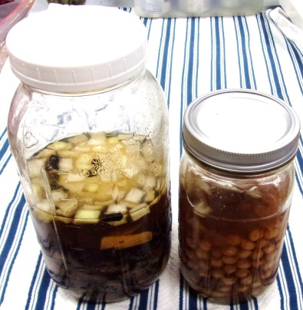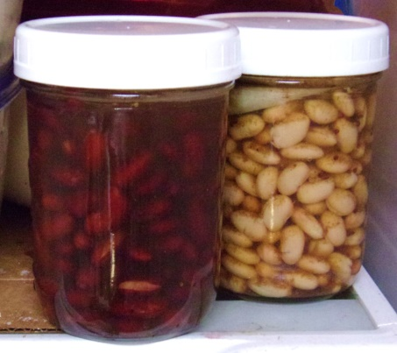
Variety pickles – made with above broth
- Asparagus with onion/garlic plus caraway
- Beans (multiple canned/cooked with garlic/onion) celery seed
- Carrots
- Eggs
- French Bean (green)
- Onions
- Multi veg pickle
Wash & prep vegetable. Put into container. Pour broth over. Fridge 2 days before eating
41. _To pickle Cucumbers._ Source: Queen’like Closet
Take the least you can get, and lay a layer of Cucumbers, and then a layer of beaten Spices, Dill, and Bay Leaves, and so do till you have filled your Pot, and let the Spices, Dill, and Bay Leaves cover them, then fill up your Pot with the best Wine Vinegar, and a little Salt, and so keep them.
Sliced Turneps also very thin, in some Vinegar, Pepper and a little Salt, do make a very good Sallad, but they will keep but six Weeks.
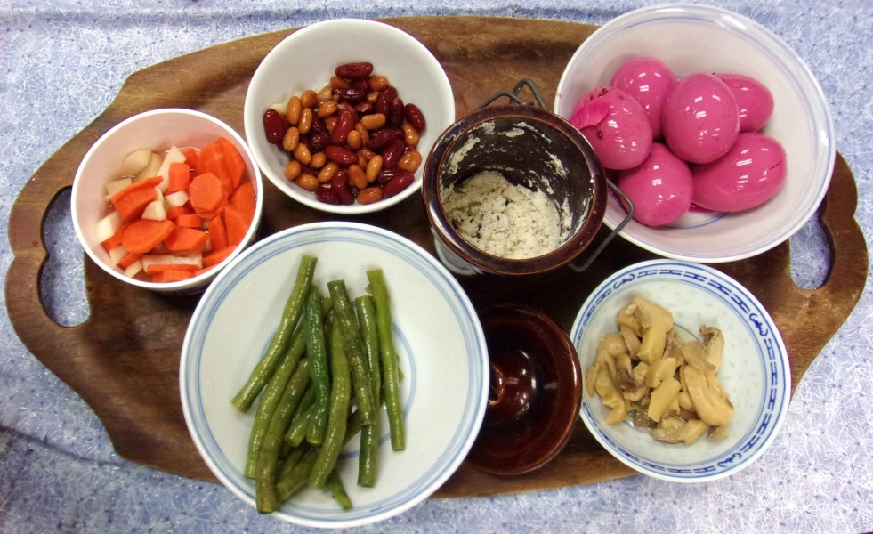
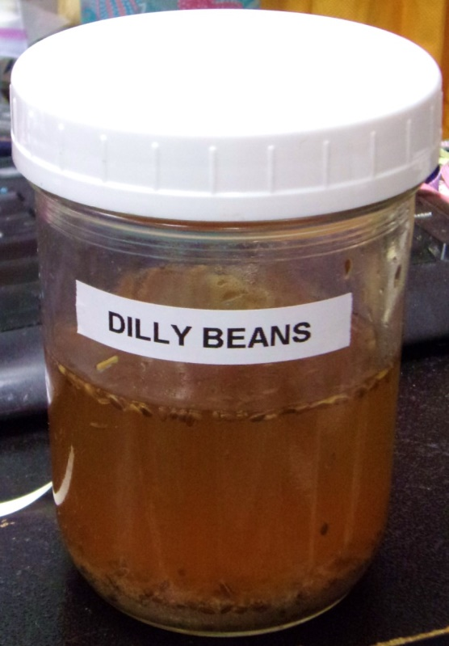
They were enjoyed so much that there’s nothing but the jar left!!!
Dilly Beans
- fresh green beans
- Pint jar
- Pickle broth
- 1 Tbsp dill seed
Method
- Wash your green beans.
- Take the straightest ones and cut to fit the jar, at least cutting the ends off the bean.
- Pack tightly into the jar.
- Add dill seed to the tops of the beans
- Take previously made, cold, pickling broth and pour over packed beans.
- Screw jar lid down, but not tightly.
- Refrigerate, at least overnight, screwing the lid down tightly about 12 hours after putting the jar into the fridge.
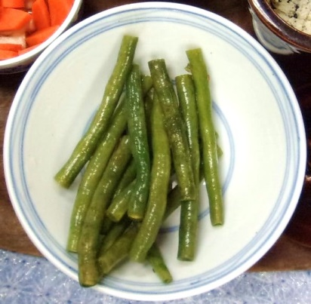
- Eat within a week.
288. _To pickle French Beans._ Source: Queen’like Closet
Take them before they be too old, and boil them tender, then put them into a pickle made with Vinegar and Salt, and so keep them; it is a very good and pleasant Sallad.

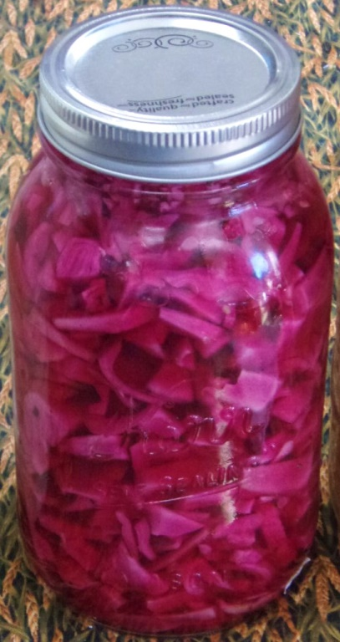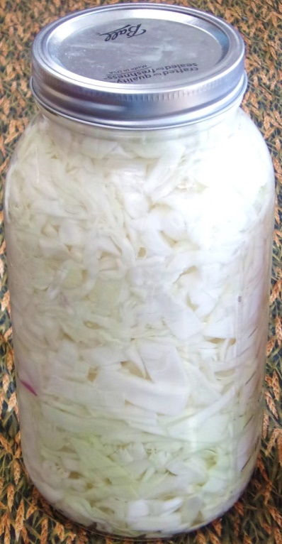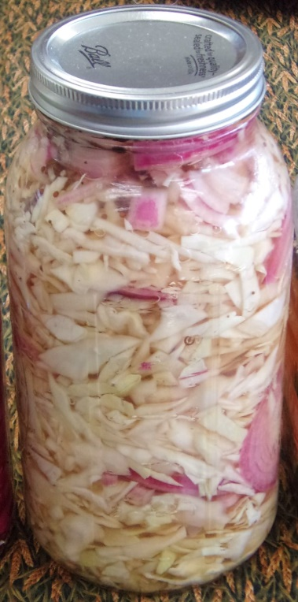
Pickled Cabbage
- medium head of cabbage (or 2 pkg deli slaw mix)
- 2 onion
- 4 Ball jars
- 8 cups vinegar
- 4 cups water
- 1 cup salt
- 1 ½ cup sugar
- Caraway, Black Mustard Seed, Celery seed, Allspice, Clove (jars), Ginger (jars)
- Shred Cabbage.
- Put about a 1” layer into your jar and pound on it to pack it down.
- Add a thin slice of onion.
- Repeat until that jar is full, then do the rest.
- Add 5 whole cloves, 2 whole allspice and a good slice of ginger to the top of each jar.
- Put the vinegar and the rest into a large pot and bring to a boil.
- Pour over the cabbage and lay the lid on loosely.
- Let sit for half an hour.
- Bang the jars on the table to get the bubbles out and then fill right to the brim with the broth, so that when the lids were screwed down they run over a touch. You’re trying to exclude as much air as possible.
- Again, lay the lids on loosely and when cool, screw them down, then put the pickles in the fridge.
- Wait at least 3 days before serving.

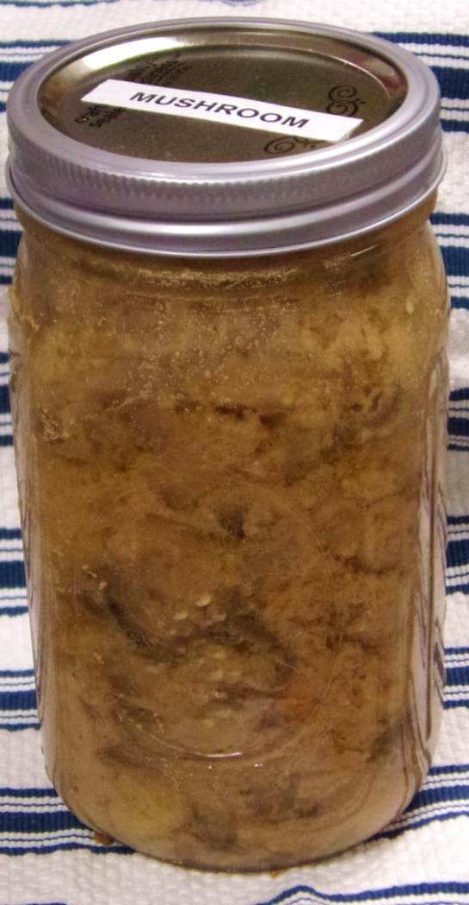
Funges pikld - makes 8 servings (SCA recipe from ‘70’s)
Ingredients
- 1 onion, thinly sliced
- 1 cup red wine vinegar
- 1 cup water
- 3 tablespoon brown sugar
- 3 tablespoon mustard powder
- 1 Tbsp mustard seed
- 1 ½ tbsp. salt
- 24 oz ounce) cans whole mushrooms, drained
- 2 slices fresh ginger
Directions
- Bring onion, vinegar, oil, sugar, and Dijon mustard to a boil in a saucepan.
- Add mushrooms and simmer until liquid is slightly reduced, 5 to 6 minutes.
- Transfer mixture to a covered container and chill. (It overflows a quart canning jar….) Add ginger slices at the 1/3 and 2/3 marks….
- Drain before serving.

Pickled eggs with beets & onion for 50 (feast servings, ½ egg per) Canned Beet Method
Ingredients
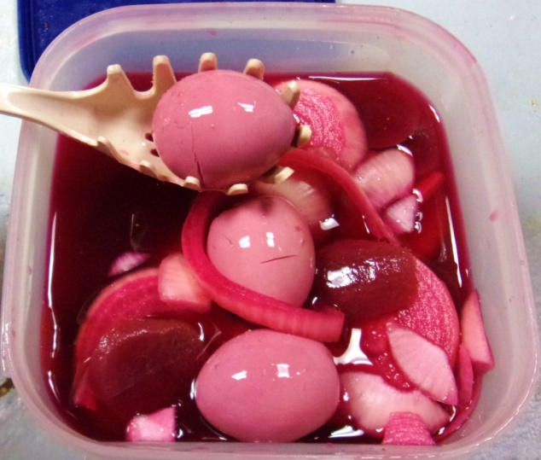
- Pickle broth (Cat’s Fridge Pickle)
- 2 Dozen Fresh eggs
- 4 white or yellow medium onions
- 2 Dozen cloves garlic
- 2 Cans pickled beets
- Caraway seed or fresh fennel (one or the other!)
- 2 or 3 quart jars.
Method
- Slice onions and sliver or press garlic.
- Add to pickle broth with the sugar and simmer until cooked, stirring until the sugar dissolves.
- Strain solids. Reserve liquid. Let stand until cool. (overnight in fridge)
- Hard-boil eggs, shell and cool overnight.
- Use two single quart containers and put a dozen eggs in each one. (YMMV, that’s why you should have 3 jars.
- Sprinkle well with caraway or chopped fresh fennel
- Put ½ the onion/garlic solids in each
- Tuck the beets into the jars.
- Add enough of the pickle broth to cover and let stand overnight. Taste the broth and add more spices to taste. Keep in the fridge.
- Shake each day for 3 days, then eat. These should be eaten within two weeks.
Note – If you like it hot add a touch of prepared horseradish to each container. 1/8 teaspoon each. Don’t add more unless it’s still “too tame” 24 hours later!

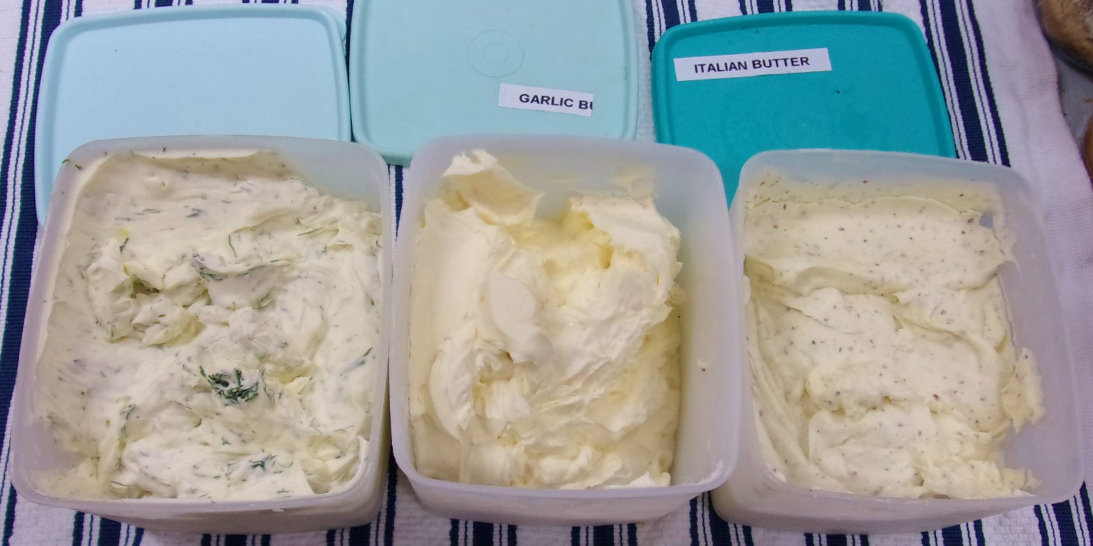
Flavored Butters – Somewhat period, at least peri-oid…
- General Directions - Peel the paper off the cubes of 1 pound of butter, set in a mixing bowl (or food processor bowl), covered, and let stand at room temperature for an hour, at least.
- Add the flavoring ingredients to the butter and whip, mix or process until “smooth” (some butters, like nut butters, stay lumpy)
- Put into air-tight containers, let sit overnight and keep in the fridge for up to a month. Some need “standing time”
- Quantity can be halved.
Variations
Dill/Onion Butter
2/3 cup fresh dill (or 1/3 cup dried)
¼ cup onions, chopped
1 clove garlic
Garlic butter
2 bulbs of garlic, peeled and chopped (you can use ¼ cup of pre-minced stuff from the produce department of the grocery store, instead)
Pinch of dill weed, ground caraway, or Italian seasoning (one of these, only!)
Herb/Onion butter – ¼ cup of mixed, dried, crushed herbs (thyme), plus ½ an onion
Honey butter – great on morning toast
½ cup of honey
Hugh Plat's "Delightes for Ladies" butter – Add 1 tsp food grade essential oil of sage, cinnamon, nutmegs, mace, rosemary or whatever suits. Make a test batch because some oils are stronger, some weaker.
Spiced Honey butter – Wonderful on pancakes
½ of honey
1 tbsp ground nutmeg
1 tsp cinnamon
1 tsp vanilla flavoring
Hugh Plat's "Jewel-house of Arte & Nature" butters
Spring Sage, etc. butter - In May/June when the sage bushes have very tender new leaves, add about ¼ cup of finely chopped very young fresh sage leaves and eat that day (else it sometimes molds….) Else add 1 tsp food grade essential oil of sage EO (as above) or cinnamon, mace, or cloves.
Sweet Rose butter - Add 1 TBSP of rose water, plus ¼ cup of sugar.
Colored butter – Can be made with regular paste coloring, or by adding ¼ cup dried, finely ground roseleaves, cowslip leaves, violet or marigold leaves.
Rum butter – Good on raisin bread or English muffins
2 tbsp of real dark rum or rum flavoring
1 tbsp raw sugar
Maple butter – use this instead of butter and syrup, less messy to serve
½ cup of real maple syrup, or
½ cup of real maple sugar or
½ cup of karo syrup and 2 tbsp maple flavoring
Quick Italian butter – Good on sandwiches or toast with dinner
Add 1 packet of 4 seasons Italian salad dressing mix. (Can use right away)
Fresh Dill butter – A good sandwich spread
½ cup of fresh chopped dill (don’t use stems)
Bacon and Blue Cheese Butter Recipe
6 strip bacon, cut into 3 pieces
1 pound butter , softened to room temperature
1 cup blue cheese, crumbled
Cook bacon. Drain, pat dry and chop the bacon into very fine pieces. Add the bacon, blue cheese crumbles to the butter. Fridge overnight, at least.

Sources for butters
Picked up from Stefan’s Florilegium – Mostly honey butter seems to have been a medicine, in period, but there is some evidence for flavored butters earlier, not in recipe books, but descriptions. However the Florilegium has the following:
Hugh Plat's "Delightes for Ladies", which is dated 1609 and is thus, according to the arbitrary cut-off date set by Corpora, just past our period of study. “Most Dainte Butter. This is done by mixing a few dropps of the extracted oyle of sage, cinamon, nutmegs, mace, etc. in the making vp of your butter: for oyle and butter will incorporate and agree verie kindely and naturally together.
Another Plat source, "Jewel-house of Arte & Nature", dated 1594.
2. How to make sundry sorts of most dainty butter with the saide oils. In the month of May, it is very usuall with us to eat some of the smallest, and youngest sage leaves with butter in a morning, and I think the common use thereof doth sufficiently commende the same to be wholsome, in stead whereof all those which delighte in this heabe may cause a few droppes of the oile of sage to be well wrought, or tempered with the butter when it is new taken out of the cherne, until they find the same strong enough in taste to their owne liking; and this way I accoumpt much more wholsomer then the first, wherin you will finde a far more lively and penetrative tast then can be presently had out of the greene herbe. This laste Sommer I did entertaine divers of my friends with this kinde of butter amongst other country dishes, as also with cinnamon, mace, and clove butter (which are all made in one selfe same manner) and I knew not whether I did please them more with this new found dish, or offend them by denying the secret unto them, who thought it very strange to find the naturall taste of herbs, and spices coueied into butter without any apparent touch of color. But I hope I have at this time satisfied their longings. Ore, if by som means or other you may not give a tincture to your creme before you chearne it, either with roseleaves, cowslep leaves, violet or marigold leaves, &c. And thereby chaunge the color of your butter. And it may be that if you wash your butter throughly wel with rose water before you dish it, and work up some fine sugar in it, that the Country people will go neere to robbe all Cocknies of their breakfasts, unlesse the dairie be well looked unto. If you would keepe butter sweete, and fresh a long time to make sops, broth or cawdle, or to butter any kinde of fishe withall in a better sorte then I have seene in the best houses where I have come, then dissolve your butter in a clean galsed, or silver vessell & in a pan, or kettle of water with a slow and gentle fire, and powre the same so dissolved, into a bason that hath some faire Water therein, and when it is cold, take away the soote, not suffering any of the curds, or whey to remain in the bottome: and if you regarde not the charge thereof, you may either the first or the second time, dissolve your Butter in Rosewater as before, working them well together, and so Clarifie it, and this butter so clarified, wil bee as sweet in tast
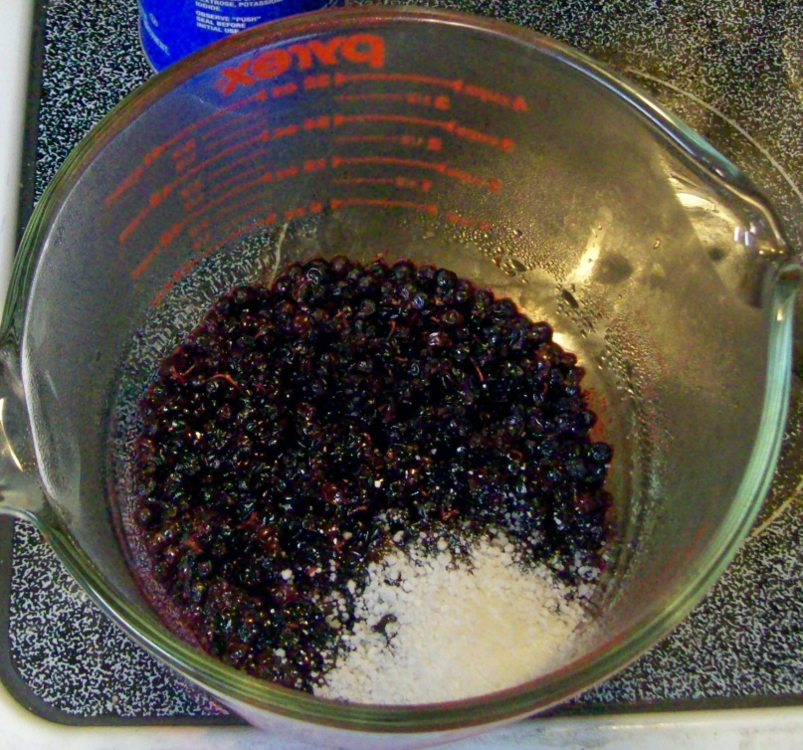
Nuker Jam – Totally not period method, but tasty….
- 1 cup berries, fresh or frozen (or grapes)
- 1/8 cup sugar
- 1 tablespoon pearl tapioca
- Dash or nutmeg, cinnamon, cardamom, mint or whatever you like.
- 4 cup pyrex measure (or larger)
- Slotted spoon or stirring spoon.
- Zap the berries for 1 minute. Stir. Repeat until berries begin to boil.
- Pull the berries out to where you can work.
- Mash them with the spoon, stirring between until you have plenty of juice and no more than ½ of the total whole berries.
- Sprinkle sugar evenly over the top.
- Sprinkle tapioca evenly over the sugar.
- Stir well! The sugar should dissolve into the juice and the tapioca will start to.
- Put back in and nuke for 1 minute. Stir. Repeat.
- Stir well again, put into small containers and refrigerate.
Note 1 - Your container needs to be tall enough that it won’t boil over.
Note 2 - In step 3, you can mash berries with seeds, (like blackberries, grapes or salal) through a strainer, but you will lose some of the yummy skin bits and may (with salal) lose a lot of the flavor.
Note 3- I always put enough into a container for a meal or a couple of snacks, now, (½ cup containers, or Tupperware™ Midgets™ but when my kids were small they would consume all of one recipe in one sitting, so I was making it every morning!

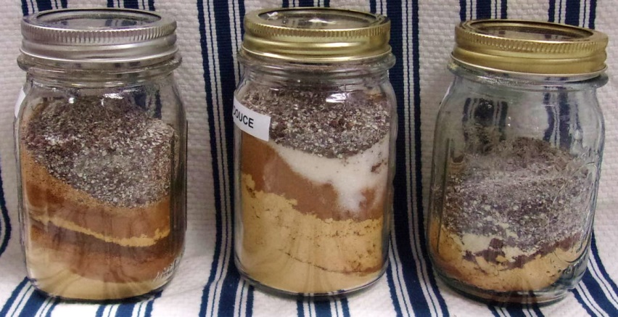
Rafaella's Salsa Fina
- 2 Ginger
- 2 Cinnamon
- 2 grains of paradise
- 2 nutmeg
- 2 mace
- 1cloves
Powder Douce
- ½ cup powdered ginger
- 1½ tsp. Grains of Paradise, ground
- 2 Tbsp. cinnamon (Ceylon), ground
- 1½ tsp. Cloves, ground
- 1 Tbsp. sugar
Powder Fort - Daniel Myers
- 3 Tbsp. ginger
- 1 1/2 Tbsp. cinnamon
- 1 tsp. cloves
- 1 tsp. cubebs (subbed grains of paradise
- 1 tsp. grains of paradise
- 1 tsp. black pepper (subbed horseradish)
Cheese spice
- 1 Caraway
- 1 Mustard
- 1 Horseradish
- 3 Salt
